1. What is Python framework?

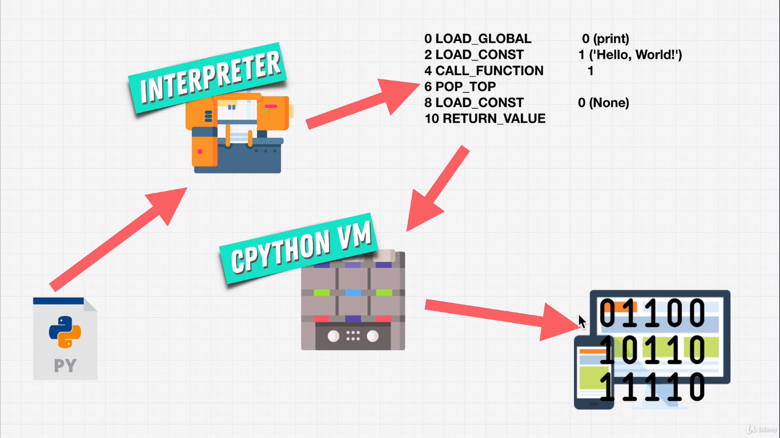

1. Python DataTypes:

Below are Python Datatypes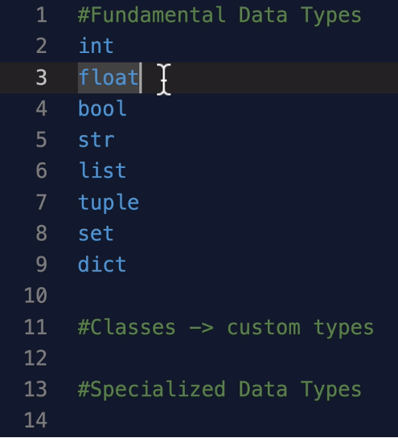



Operator precedence in Math:

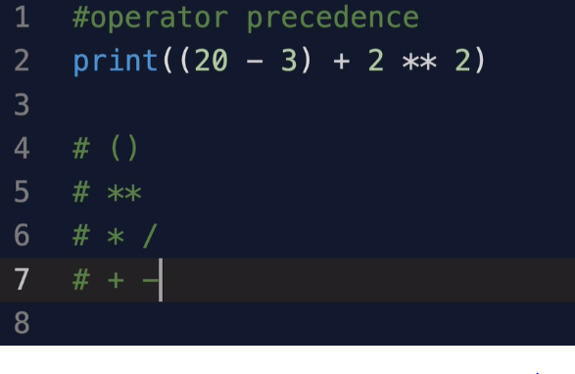

How to reverse and play out with the order of strings

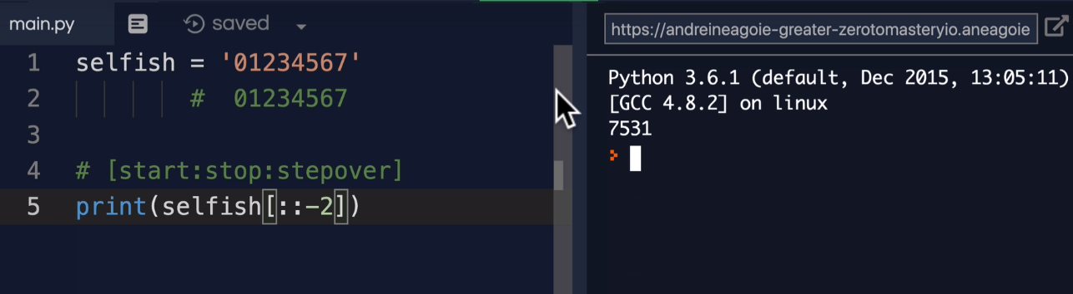

List Slicing:

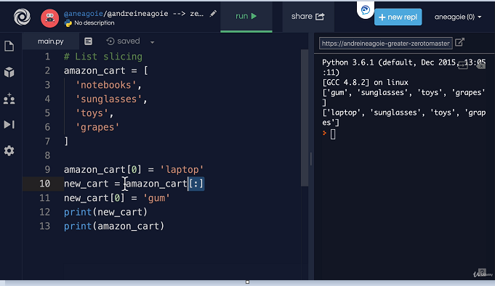

List Methods:

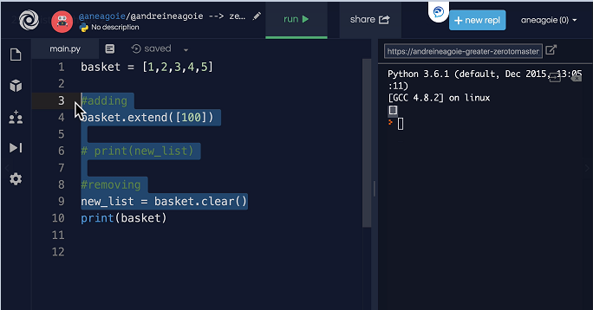

Sorted Reverse order:

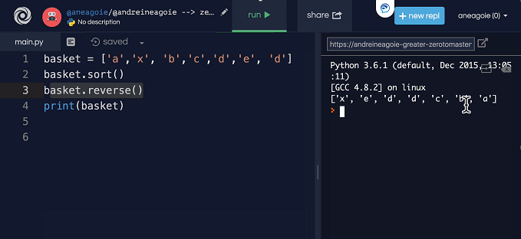

PRINT RANGE:

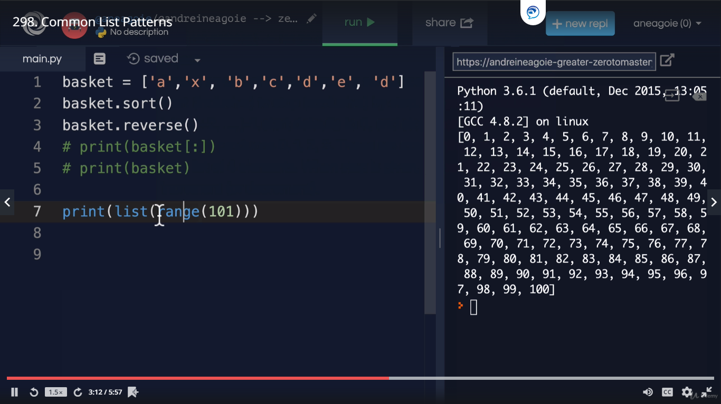

LIST JOIN:

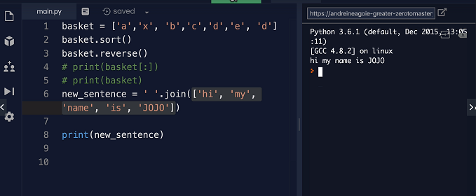

LIST Unpacking:

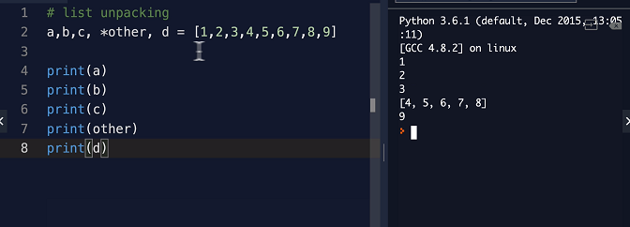

Dictionary methods:

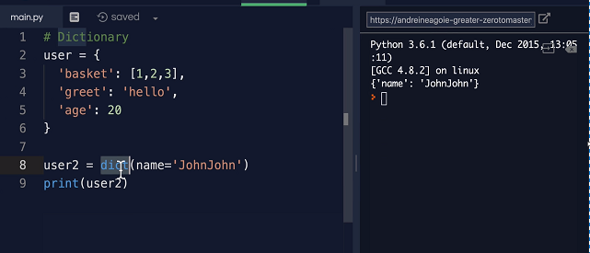

Dictionary methods update:

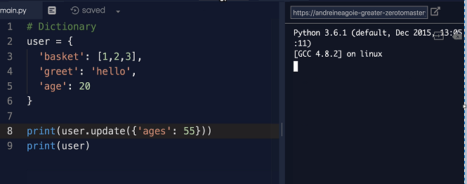

Tuple:

Tuple are mutable whereas List are immutable:

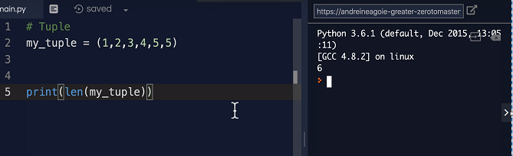

SETS:

Set has unordered unique set of records and cannot have duplicates

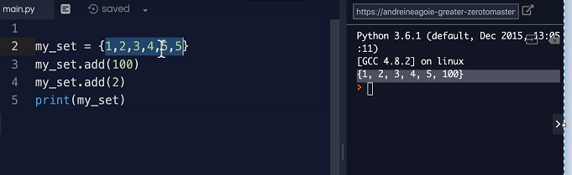

To get a unique set of records from a list

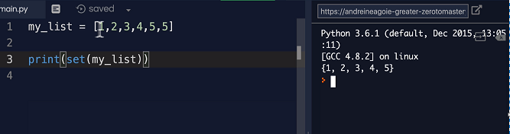

Set methods:

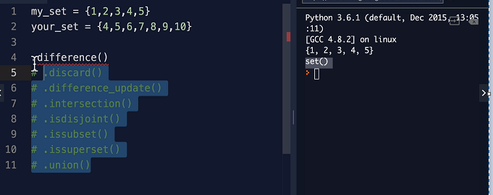

IF statement:

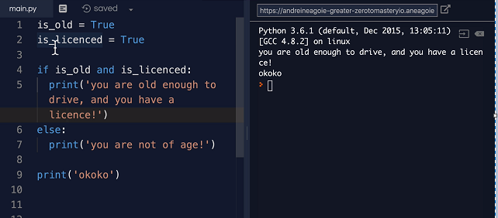

Ternary Operator for If Condition:

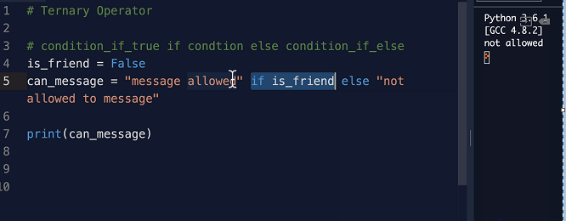

Short Circuiting ( OR statement):

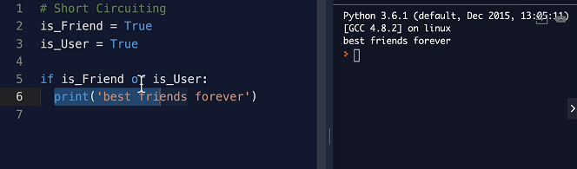

FOR loop and iterables:

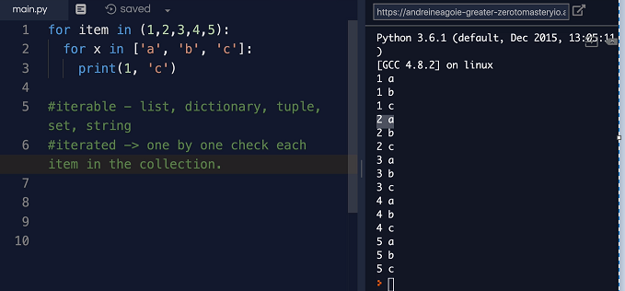

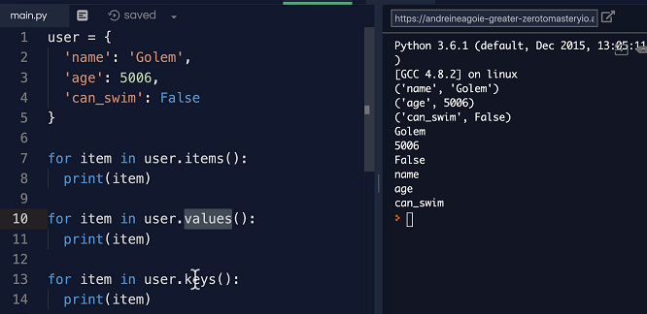

For number in range:

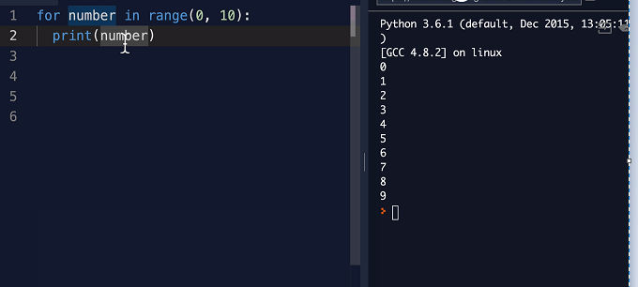

Range with stepover option

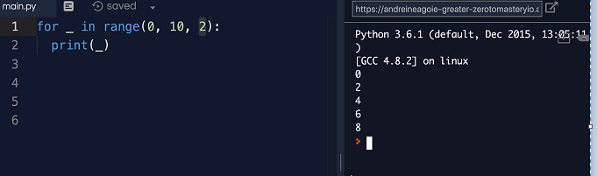

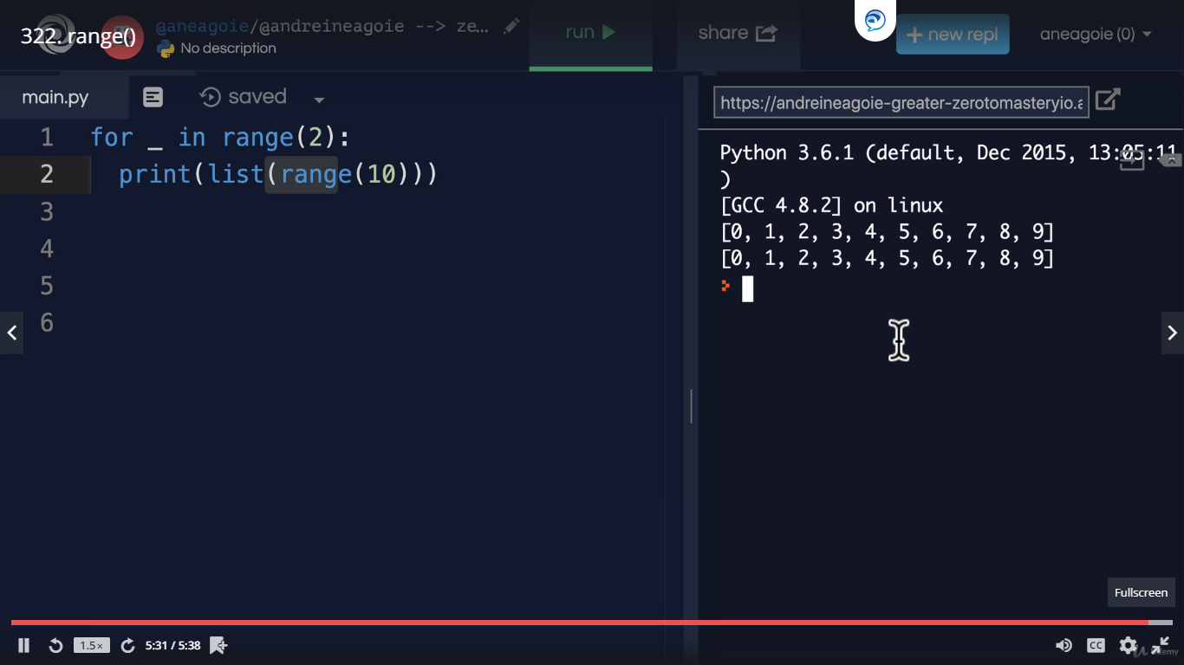

Enumerate:

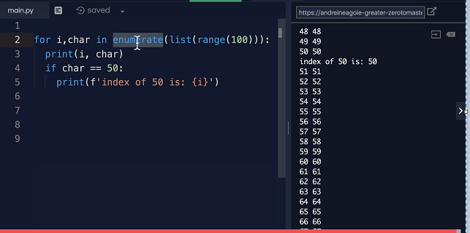

While Loop:

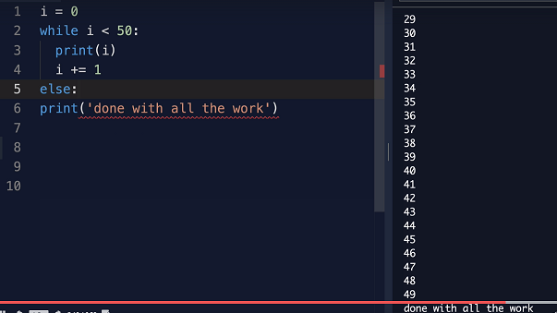

For Loop Vs While Loop:

Use For for finite list, While for infinite or big list.

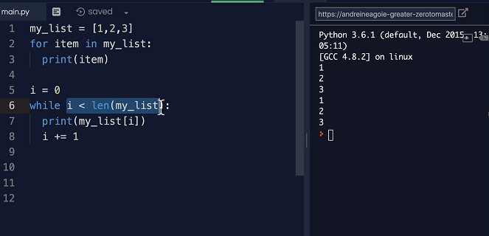

Use while loop for example in “enter correct password” for a user:

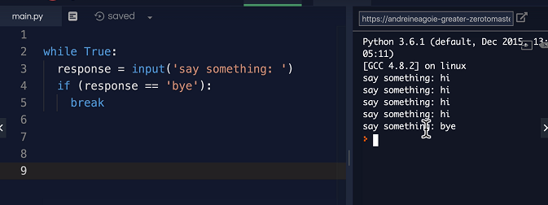

**Find duplicates in a LIST:**

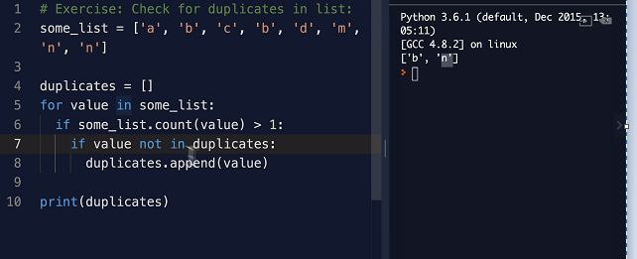

**Functions with parameters and arguments:**

**Parameters are defined in the function and arguments are passed to the function.**

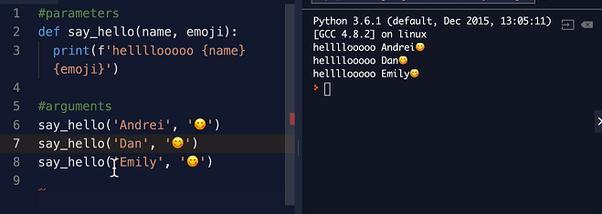

**Functions with default and parameters:**

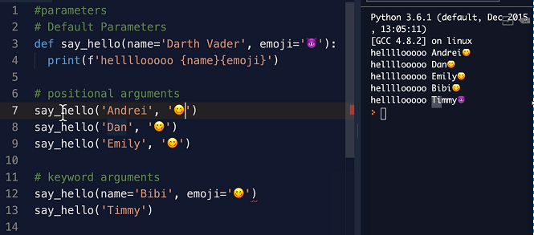

**To check if number is even or odd**

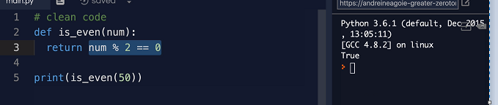

**Args, Keyword Args kwargs**

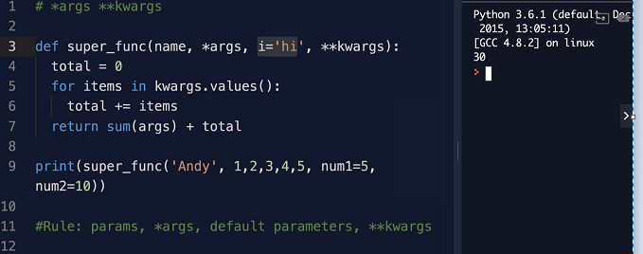

**Exercise :** Find the highest even from a list:

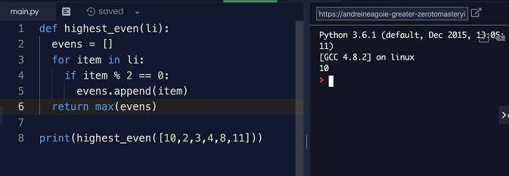

**SCOPE Rules:**

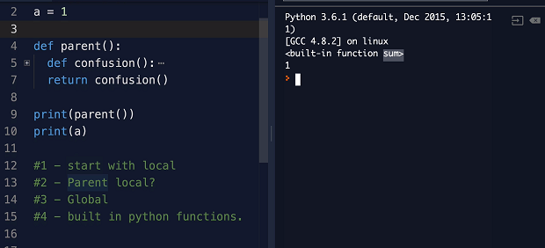

**]**

**MAP function:**

**It will do the mapping functionality.**

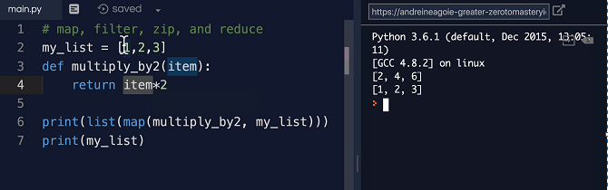

Filter() function:

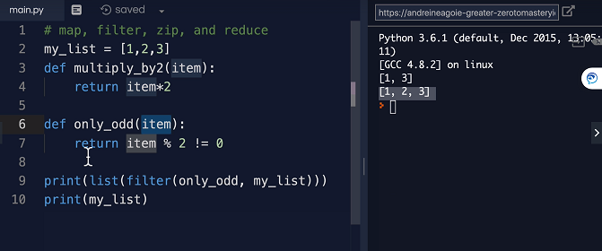

**Zip() Function:**

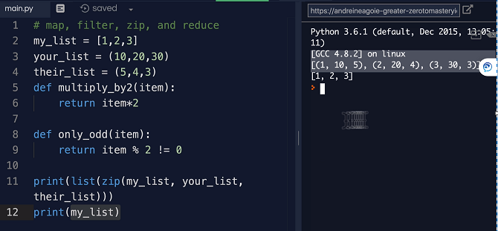

**Reduce() function:**

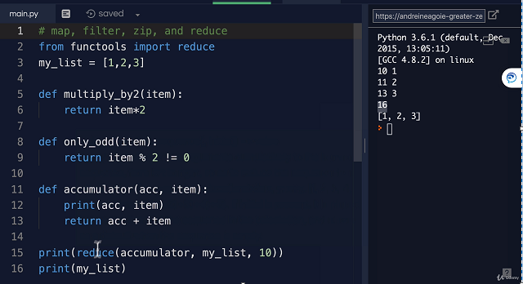

**LIST COMPREHANRSION:**

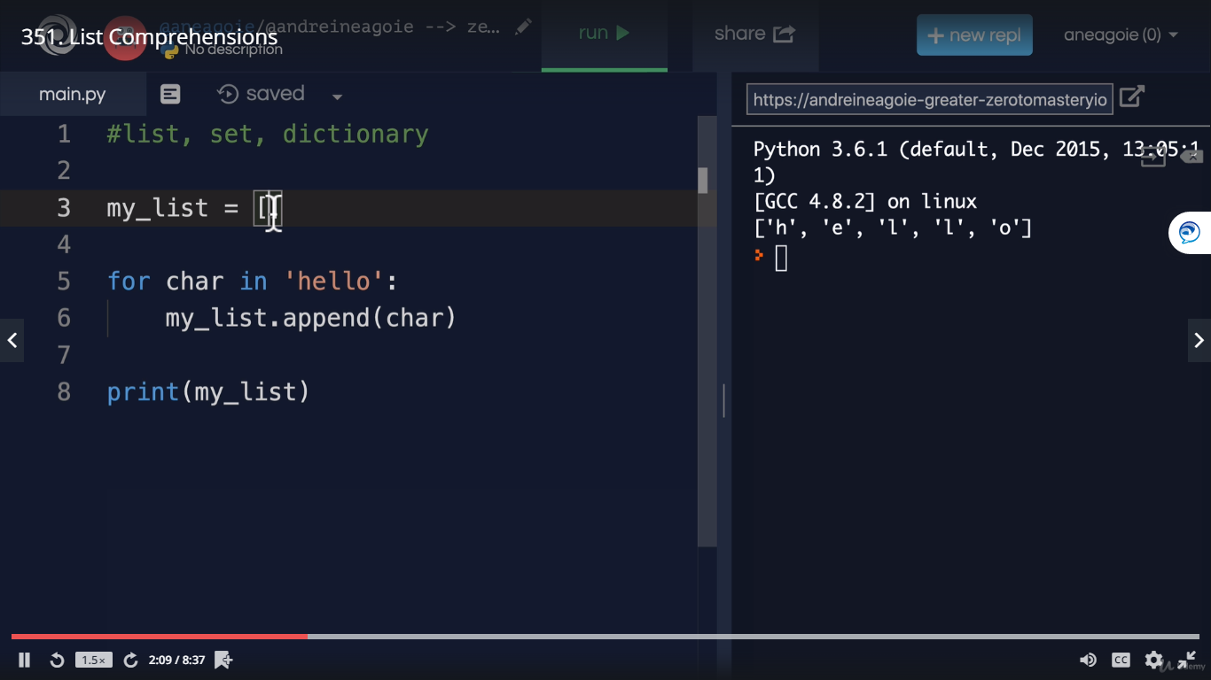

**Above can be rewritten with list comprehension:**

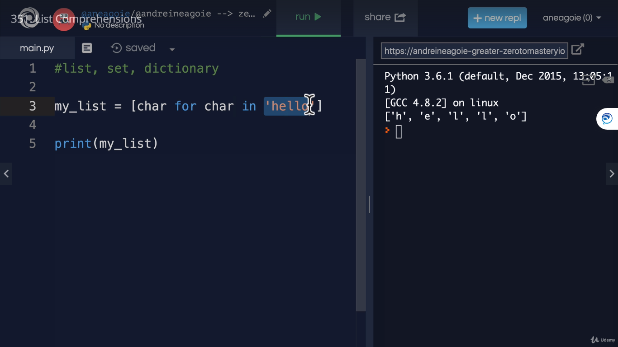

**Number with range**

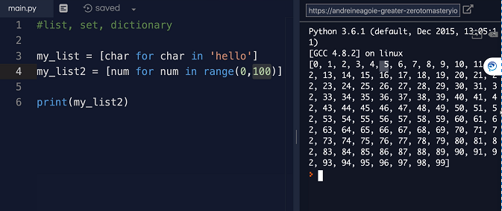

**Different math concepts with list comprehension**

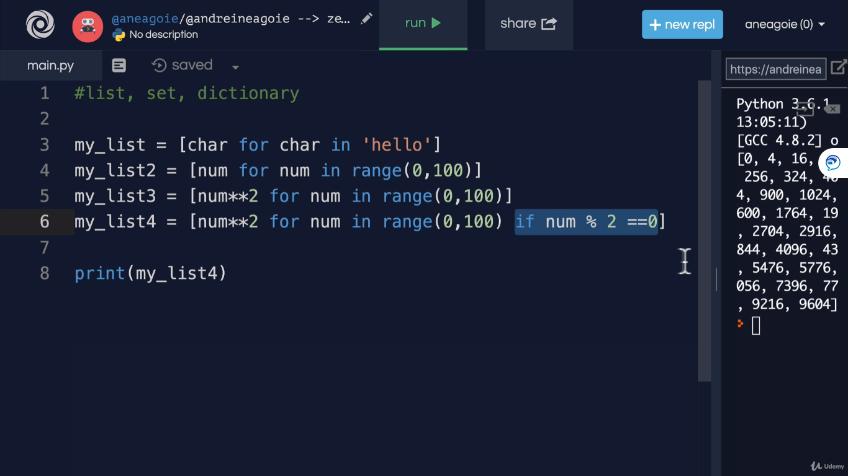

For Dictionary:

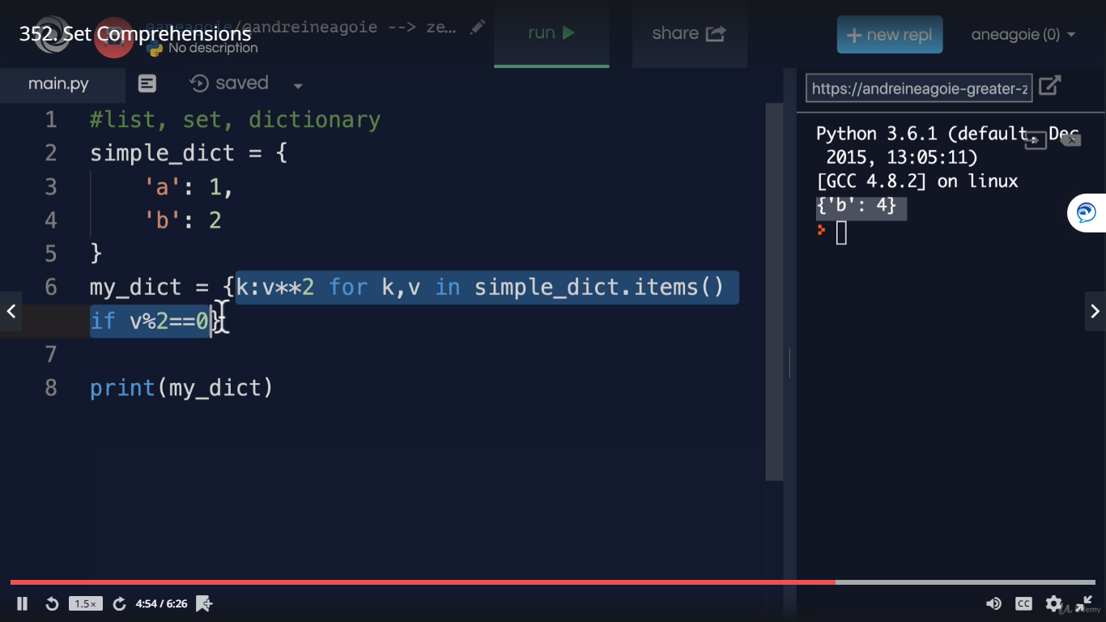

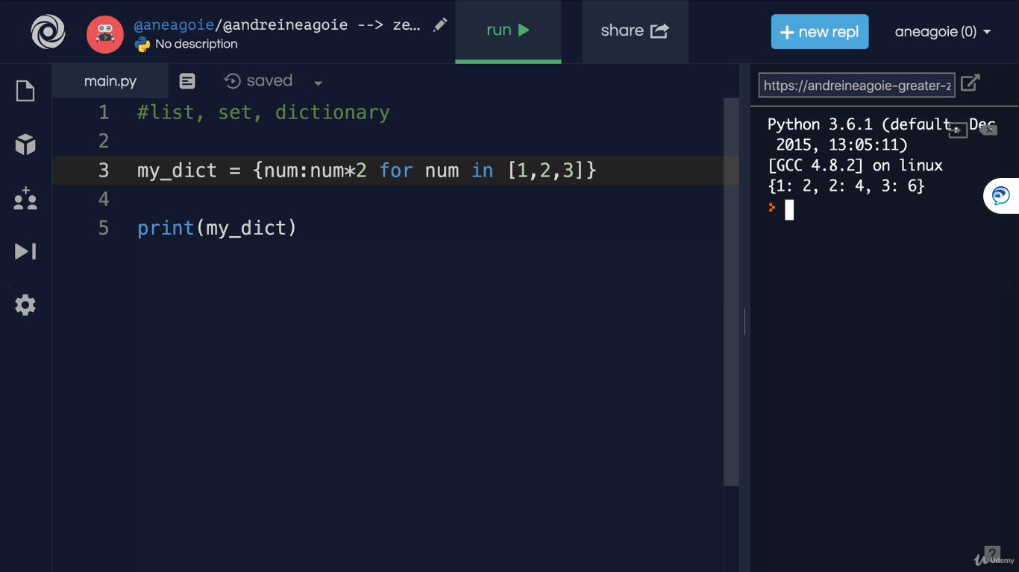

Exercise:

Convert below for finding duplicates into comprehension:

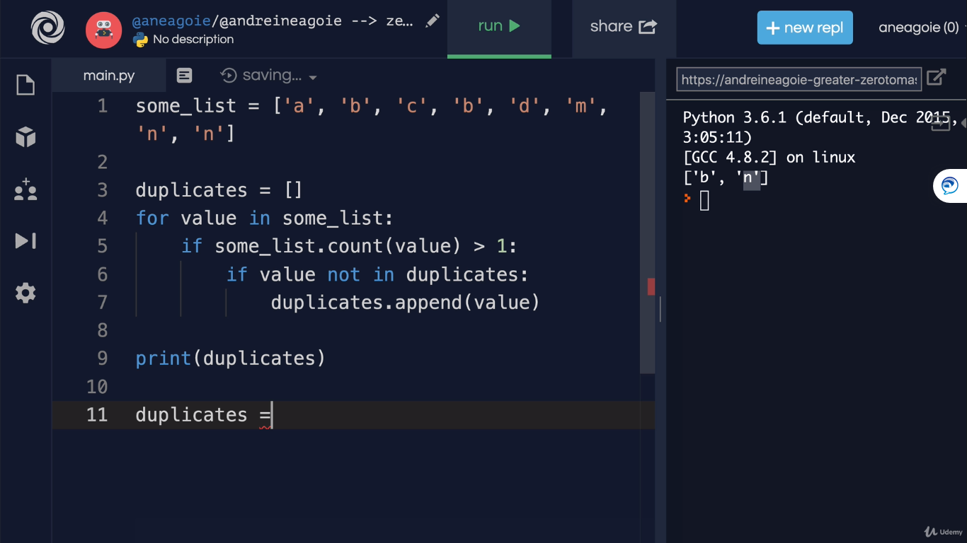

**Below with comprehension:**

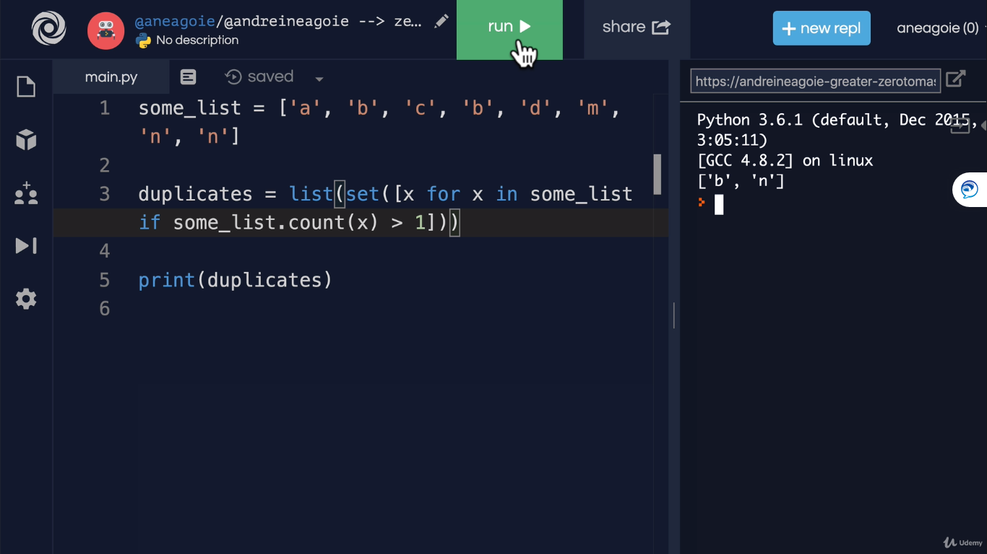

**Pandas – Concepts and commands**

1. **How to import csv file into pandas:**

Car_sales = pd.read_csv(“car-sales.csv”) (use tab to import the file)

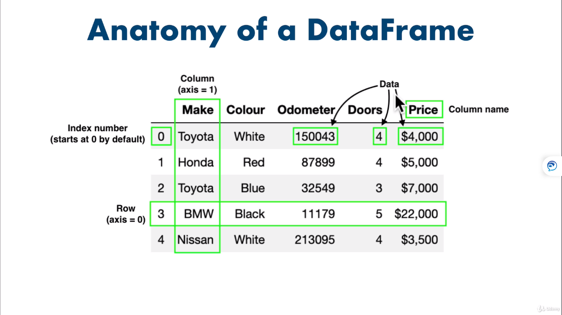

**Export to csv file**

Car_sales = pd.to_csv(“car-sales_new.csv”,index= False)

**Pandas functions to explore data:**

Car_Sales.describe()

Car_sales.info()

Car_Sales.mean()

Car_sales[“Door”].sum() 🡪 This will give sum of a particular column

Len(car_sales)

Car_sales.head(7) 🡪 This will give top 7 rows

Car_sales.tail(7) 🡪 This will give bottom 7 rows

Animals = pd.Series(“cat”,”dog”,’”snake”,index=[0,2,5])

Animals.loc[3] 🡪 This will pull the data in that index location of 3.

Animals.iloc[3] 🡪 THi swill give postion data rather than index position

**List Slicing:**

Car_sales.iloc[:3] 🡪 This will give upto index 3

**Car_sales.Make and car_sales[“Make”]** will give same results

**Filters:**

Car_sales[car_sales[“Make”] == “Toyota”]

Car_sales[car_sales[“odometer (km)”] > 10000 ]

**For Matrix view:**

For 2 columns comparison

Pd.crosstab(car_sales[“Make”] , car_sales[“Doors”])

Above will give a matrix view of the data.

**For Group by:**

Car_sales.groupby([“Make”]).mean()

Can we do some visualization:

Car_sales[“odometer (KM)”].plot()

If the plot doesn’t show up , use below before doing the plot

%matplotlib inline

Import matplotlib.pyplot as plt

To show histogram:

Car_sales[“Odometer (KM)”].hist()

**To convert dollar amount to integer:**

Car_Sales[“price”] = car_sales[“price”].str.replace(‘[\$\,\.], ‘’).astype(int)

**Manipulating data:**

Car_sales[“Make”].str.lower()

**It will not save so we need to reassign**

Car_sales[“Make”] **=** Car_sales[“Make”].str.lower()

And then again execute Car_sales

**Now how to populate null values in pandas dataframe with a mean value (null values in pandas is putup as ‘NaN’)**

Car_Sales_missing[“odometer”].fillna(car_sales_missing[“odometer”].mean(),inplace = True)

**Now to how to drop rows with null values:**

Car_sales_missing_dropped = car_sales_missing.dropna()

Now write the data with dropped null values to a new file:

Car_sales_missing_dropped.to_csv(“car_sales_missing_droppped.csv”)

**Create a new column called seats**

Seats_column = pd.Series([5,5,5,5,5])

Car_sales[“seats”] = Seats_column

Car_sales

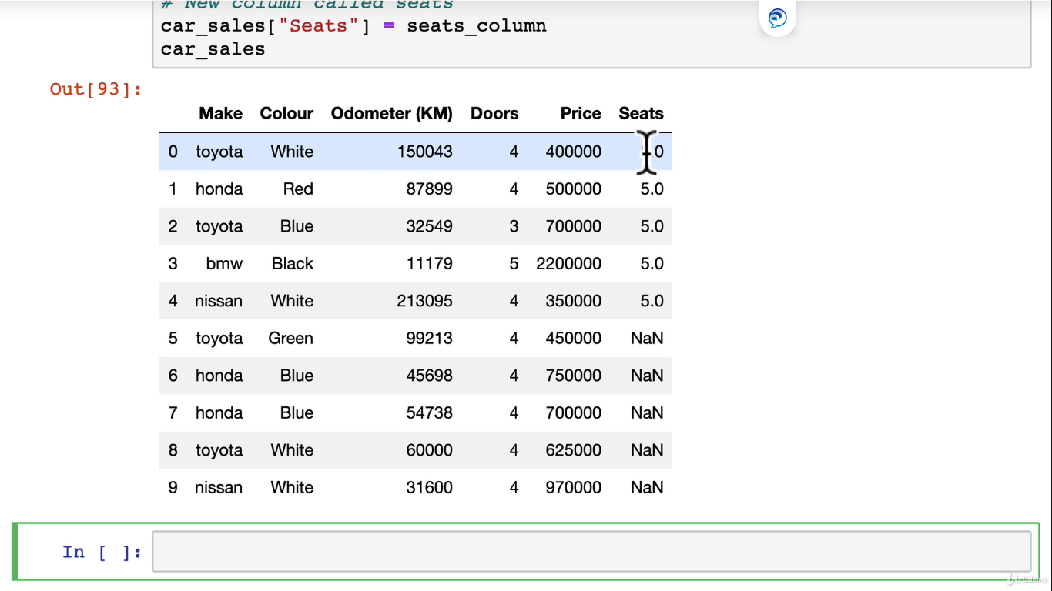

**Add column by column from list**

**#column from python list**

Fuel_economy = [7,1,2,3,5,3,4,6,4]

Car_sales[“fuel per 100KM”] = fuel_economy

Car_sales

**Now to create another column using operations:**

Car_sales[“Total fuel used”] = car_sales[“fuel per 100KM” ]/100 * car_sales[“fuel per100KM”]

Car_sales

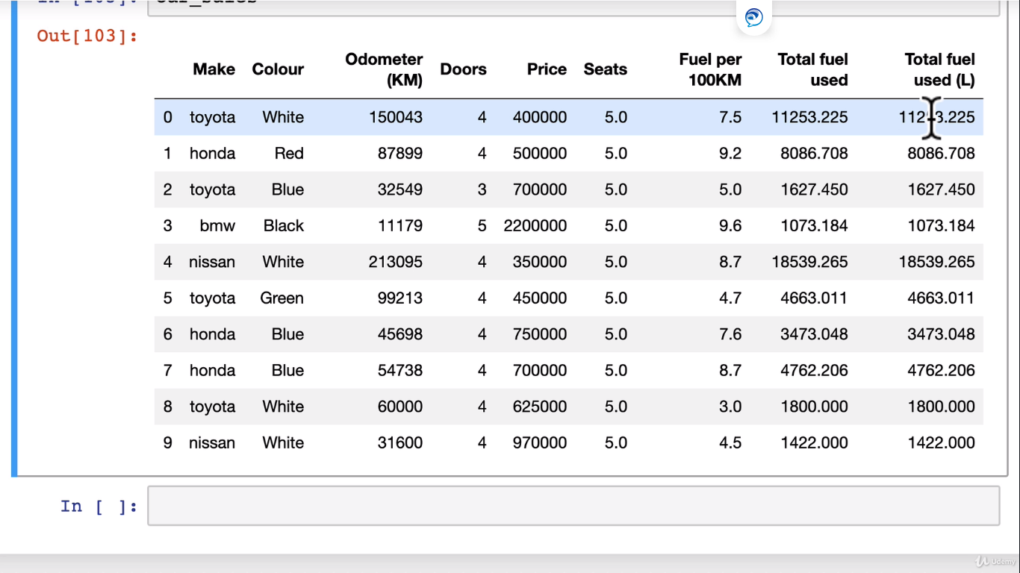

**Another way of creating a column**

Car_Sales[“Number of seats”] = 4

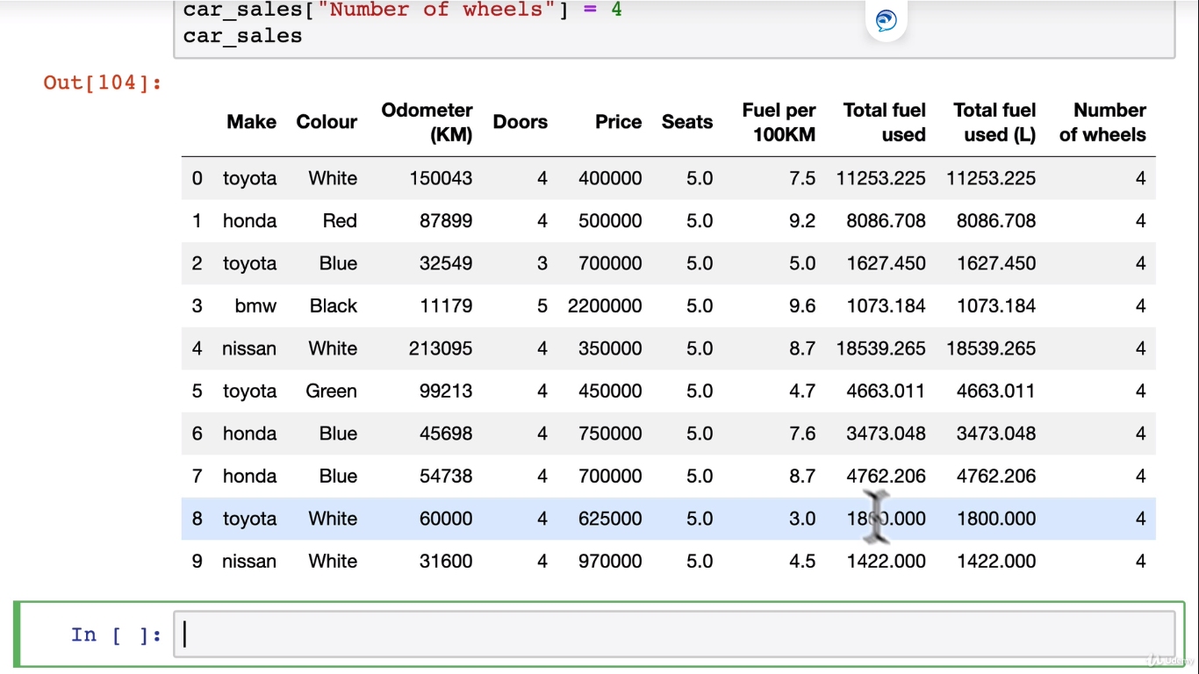

**Adding column for by Boolean value**

Car_Sales[“Passed Road Safety”] = True

Car_Sales.dtypes

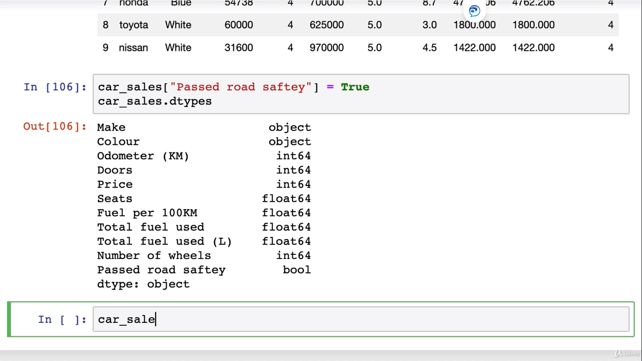

**To Drop a column:**

Car_sales.drop(“Total fuel used” , axis = 1 )

**Now how to shuffle the incoming data in order to train the machine learning model as the order of data will spoil the data set, we need to shuffle the data in order to maintain randomness else the traning set data will be mostly predictable.**

Car_sales.sample(frac=1)

Car_sales_shuffled = Car_sales.sample(frac=1)

**Car_sales_shuffled**

🡪 frac= 1 means shuffle 100% of the data , if it is 0.5 then it will shuffle 50% of the data.

If fata is large then we can shuffle on 10% of the data.

Car_sales.sample(frac=0.01)

**To reset the index position**

Car_sales_shuffled.reset_index(drop = True,inplace = True)

**How to apply operation through lambda function:**

Car_sales[“odometer (KM)”] = Car_sales[“odometer (KM)”].apply(lambda x:x/1.6)

Car_Sales

**Above will change kms to miles.**

**Numpy Concepts:**

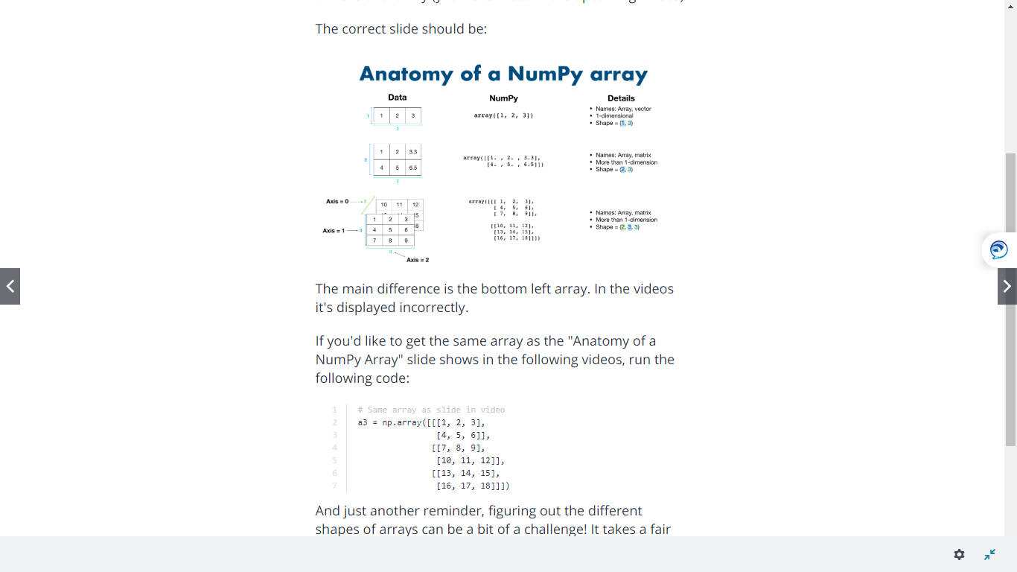

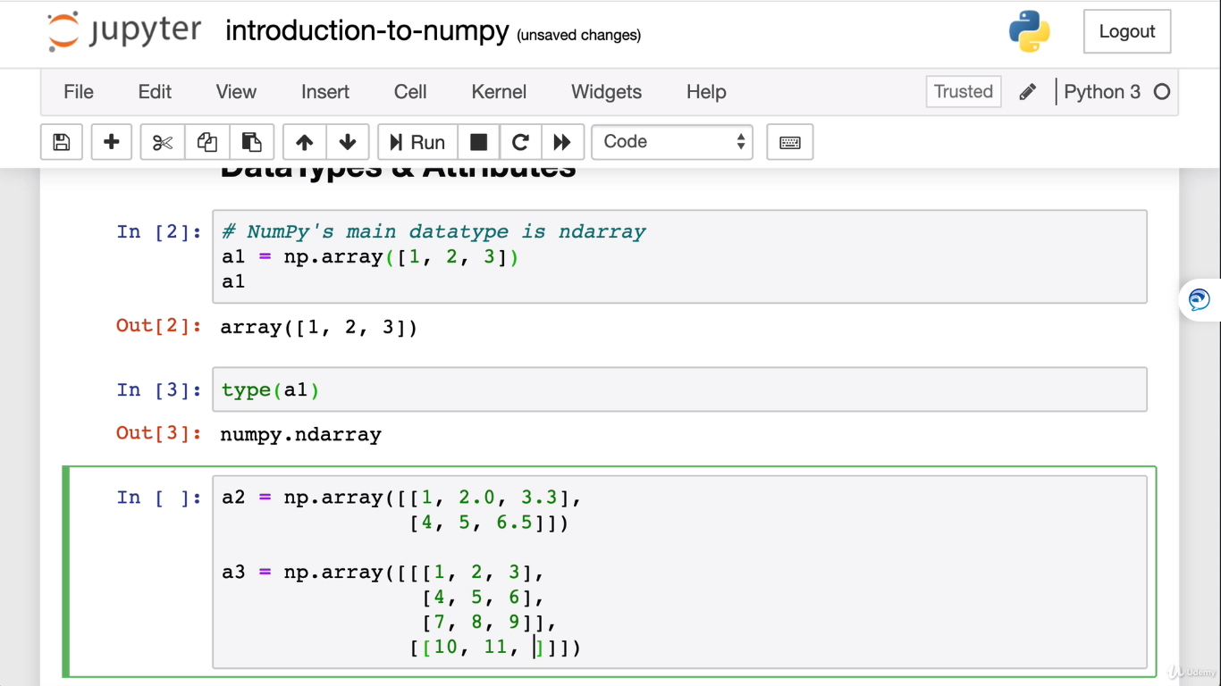

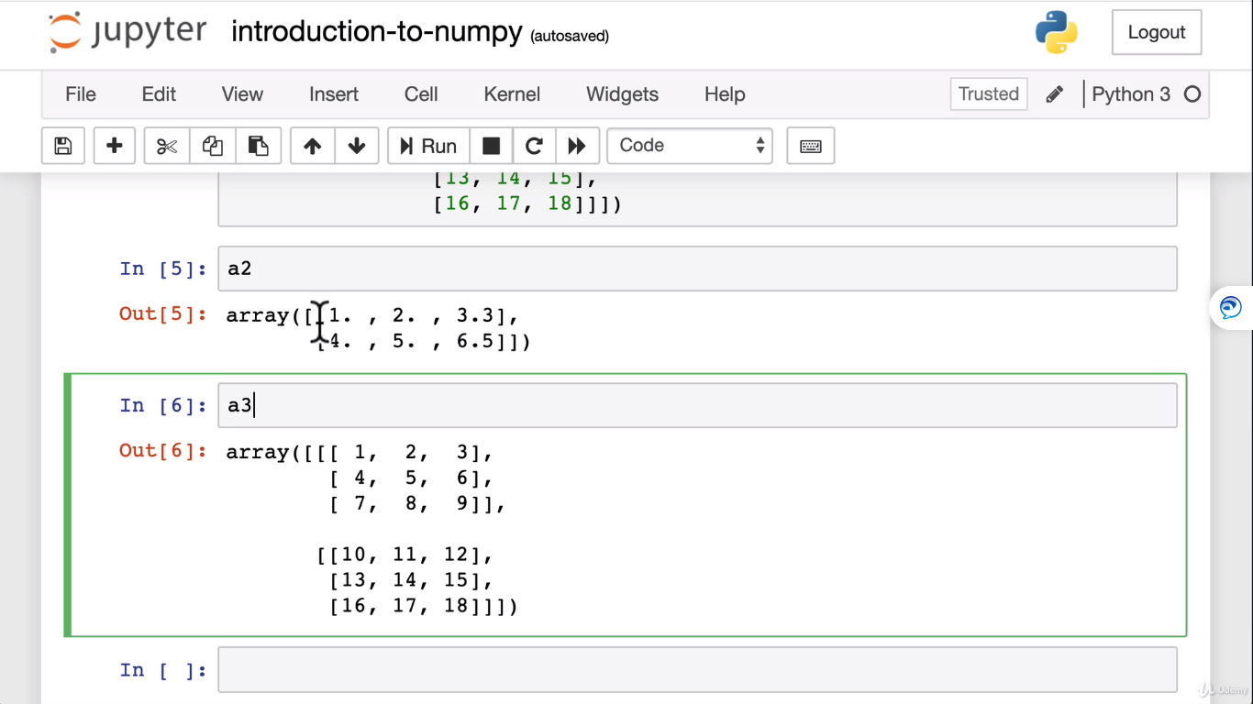

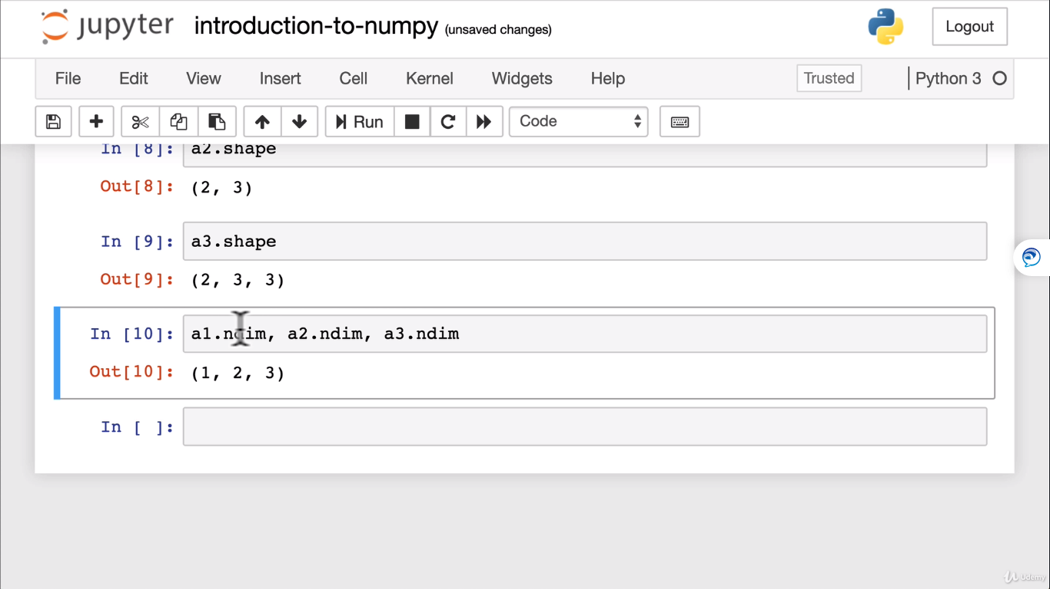

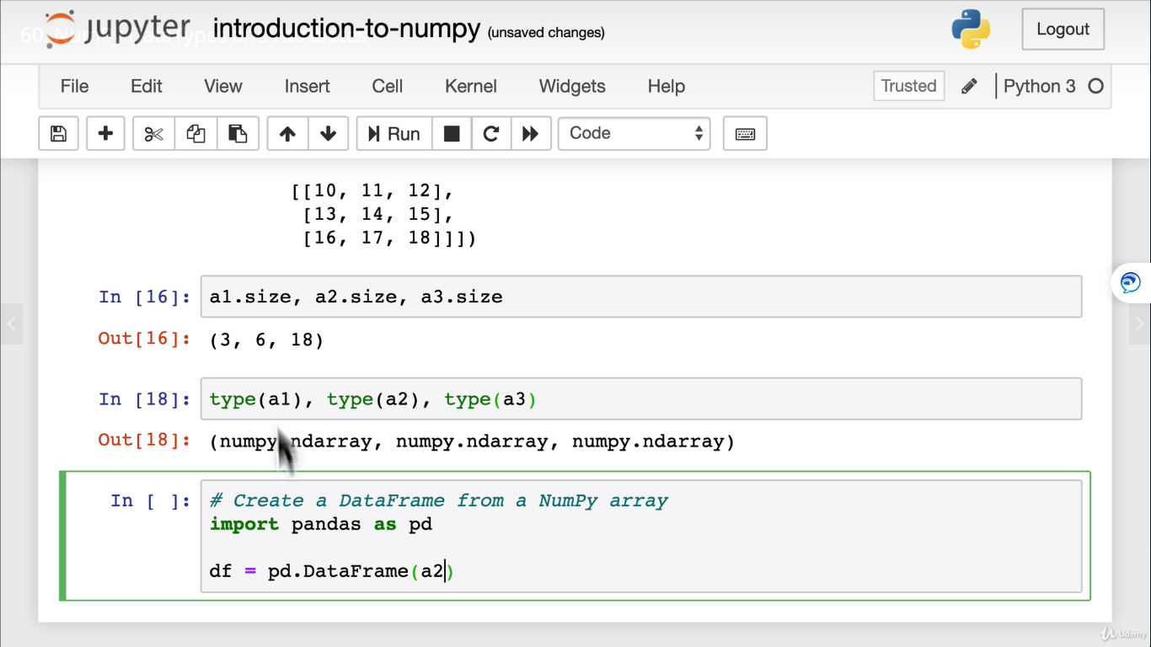

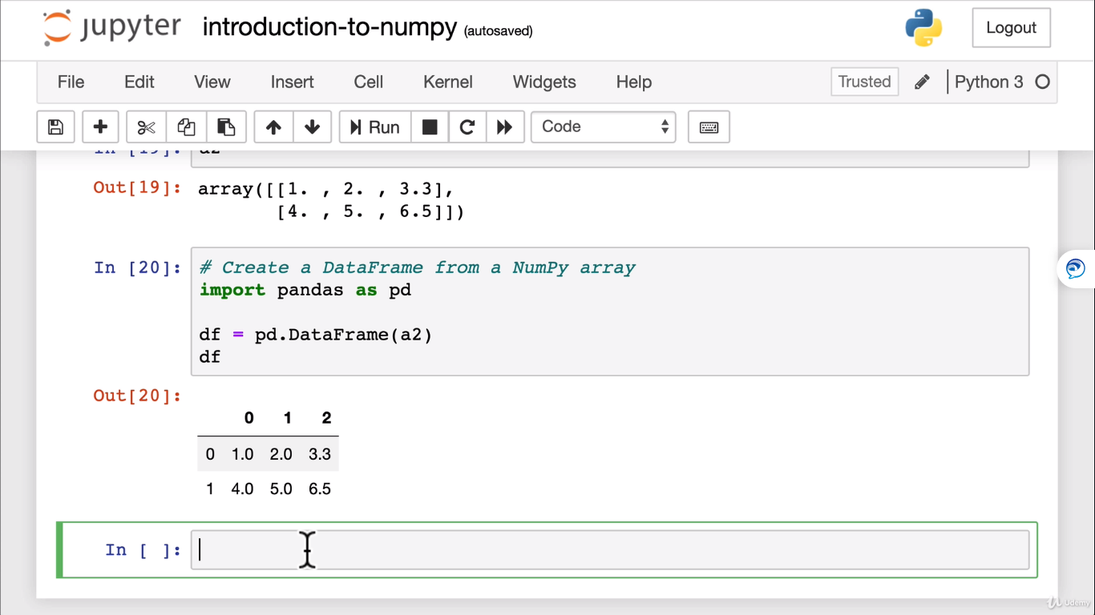

**Creating Arrays:**

Ones = np.ones((2,3))

Ones

Ones.dtype

Range_array = np.arange() 🡪 Use shift tab o see what kind of inputs you can give

Random_array = np.random.randint(0,10,size=(3,5))

Random_array.size

np.random.rand((5,3))

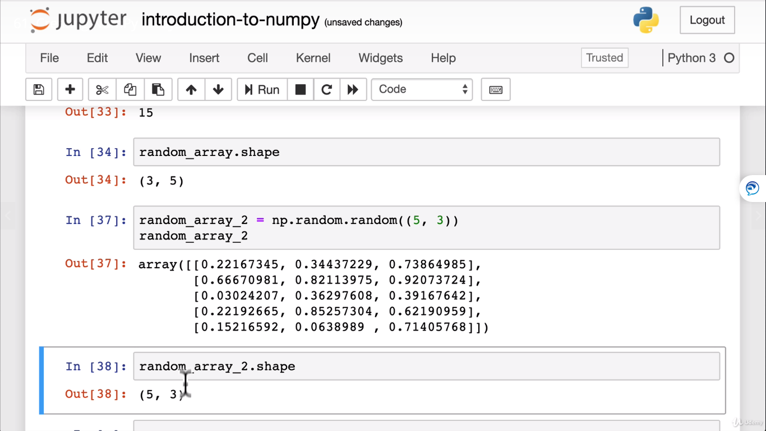

**##pseudo random numbers**

Np.random.seed()

To produce the same set of random numbers irrespective of number of times you run you will get the same random numbers.

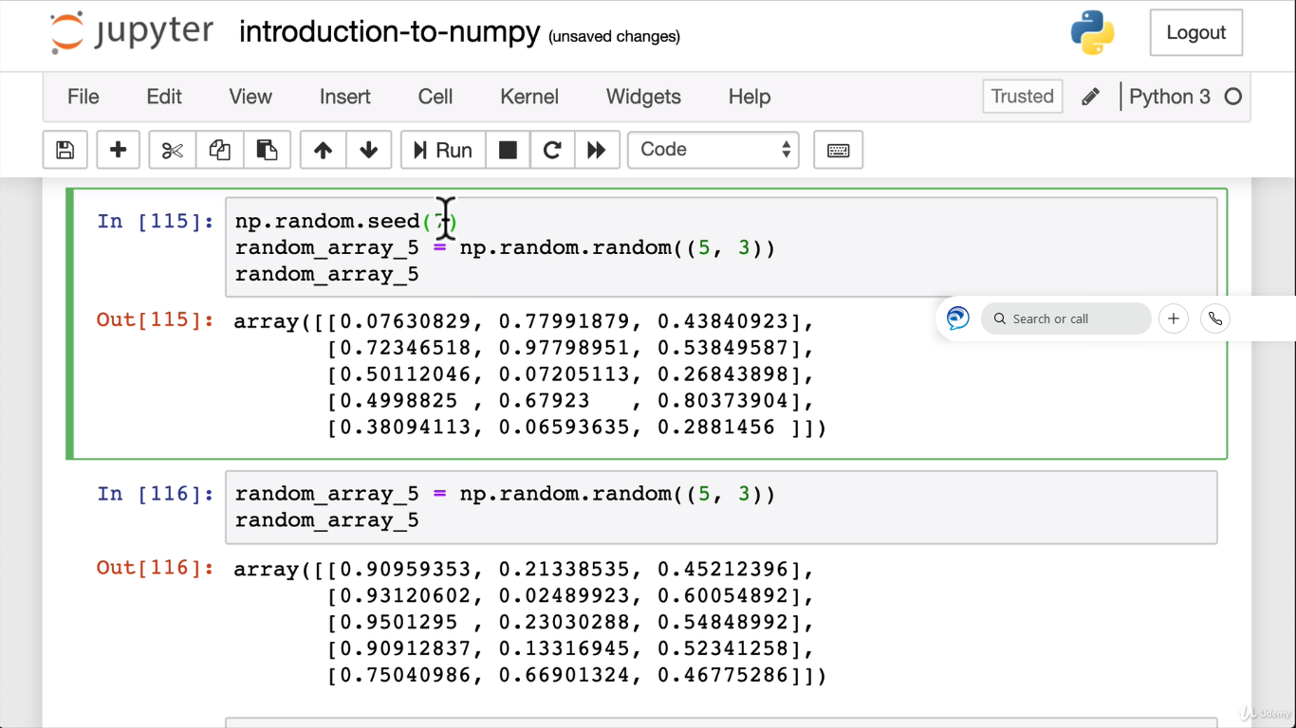

How to find unique numbers in a array?:

**Numpy array slicing:**

A4 = Np.random.randint(10, size=(2,3,4,5))

A4

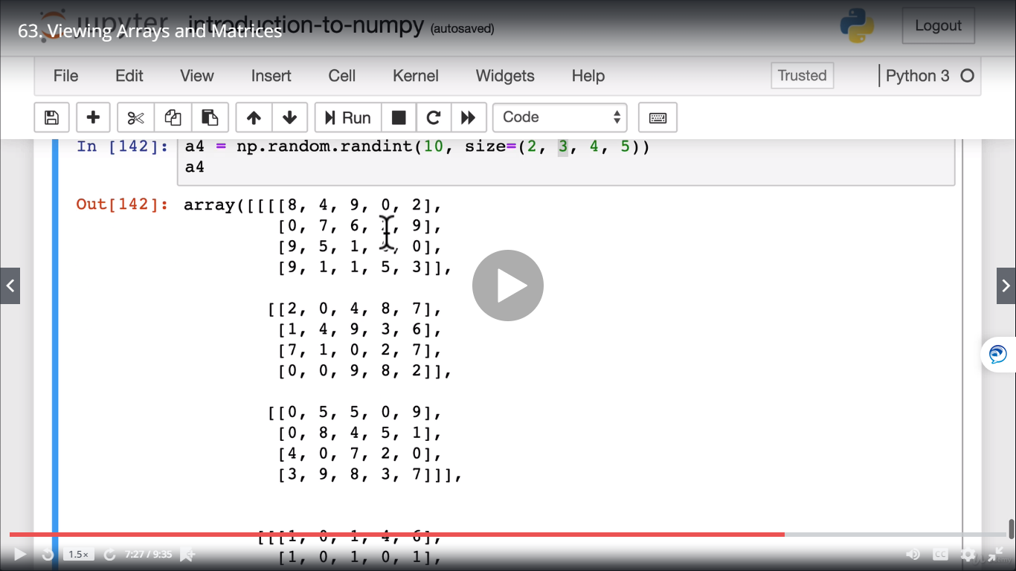

A3[:2,:2,:2] 🡪 This will give first 2 columns and rows o fthe 2 dimesnional array.

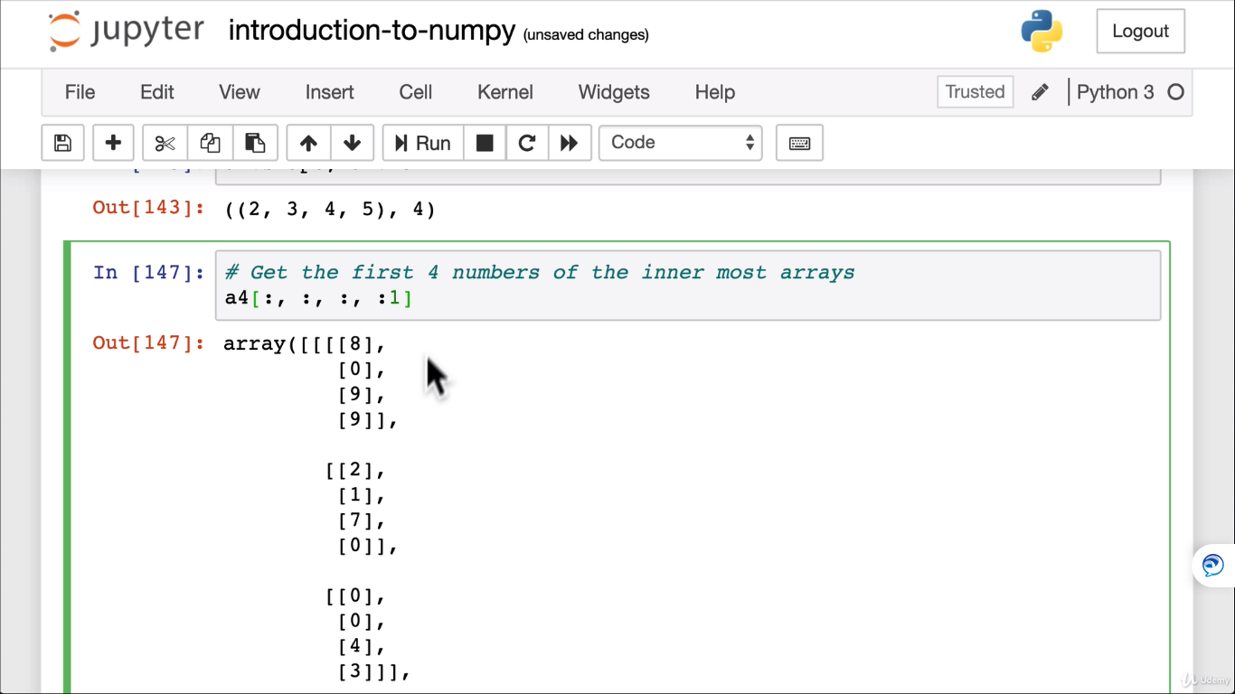

Manipulating Arrays:

A1

Ones = np.ones(3)

Ones

A1 + ones

A1 * a2

**Arithmetics:**

**Floor division rounds of the decimals:**

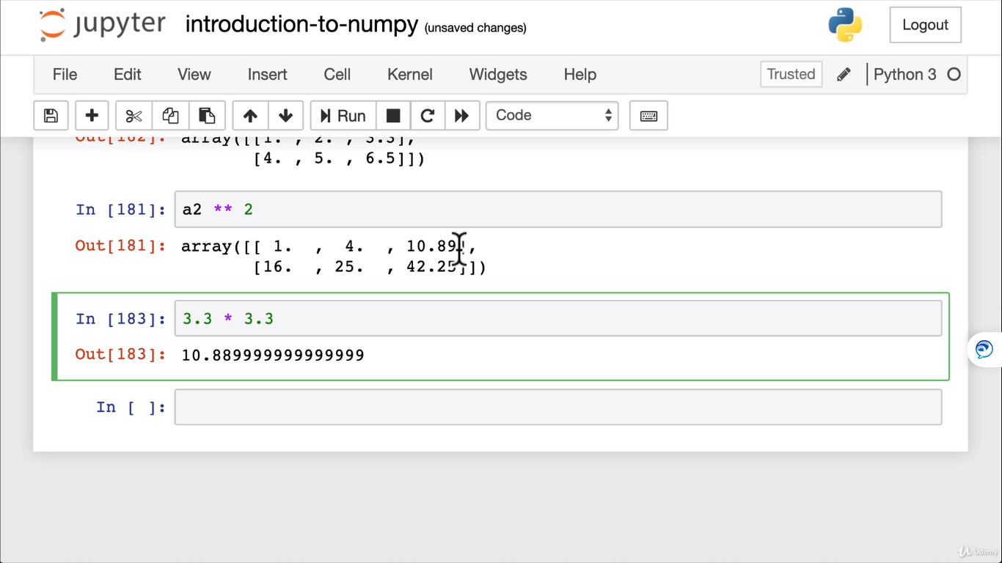

Np.square

Np.add

Np.exp(a1)

Np.log

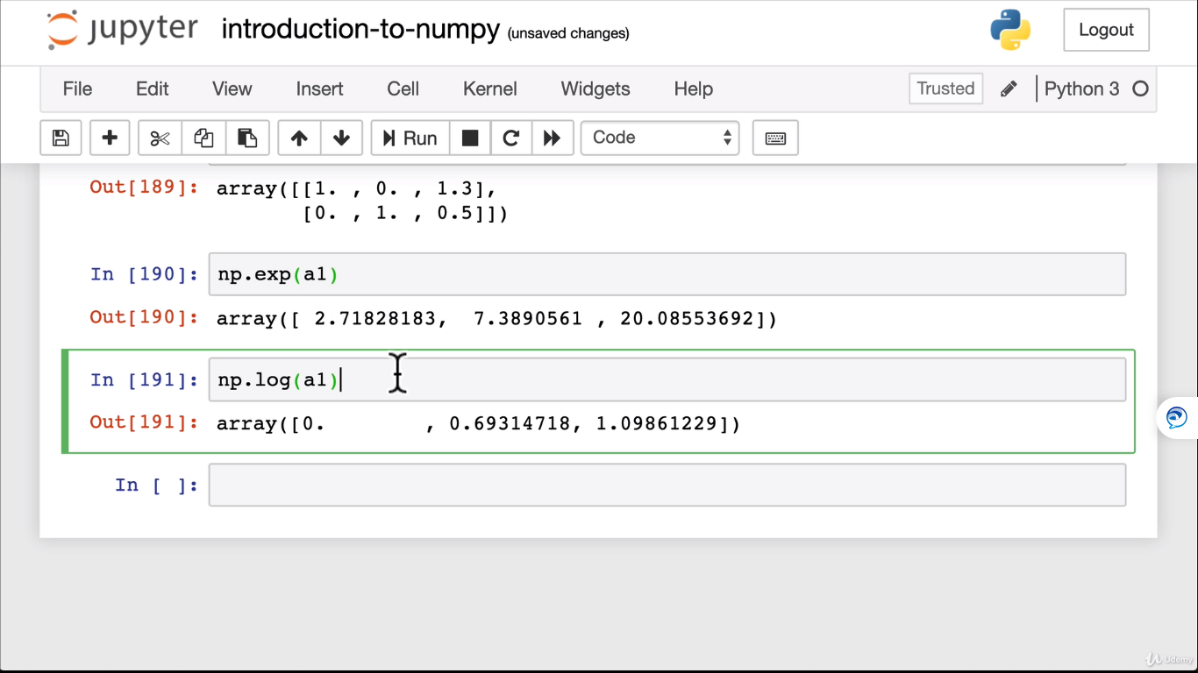

Aggregation:

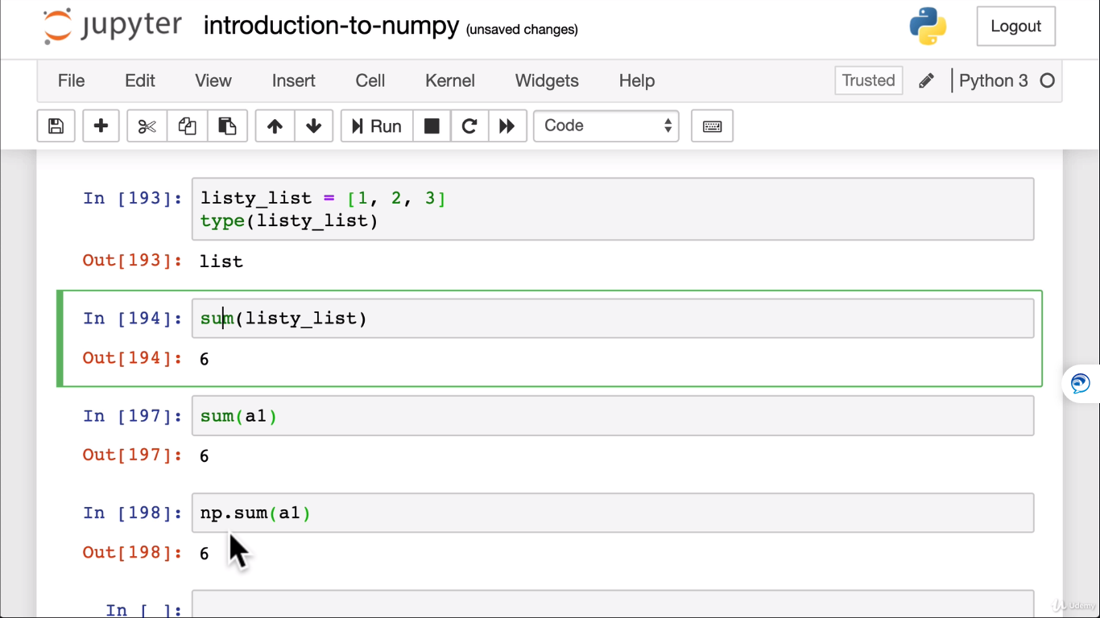

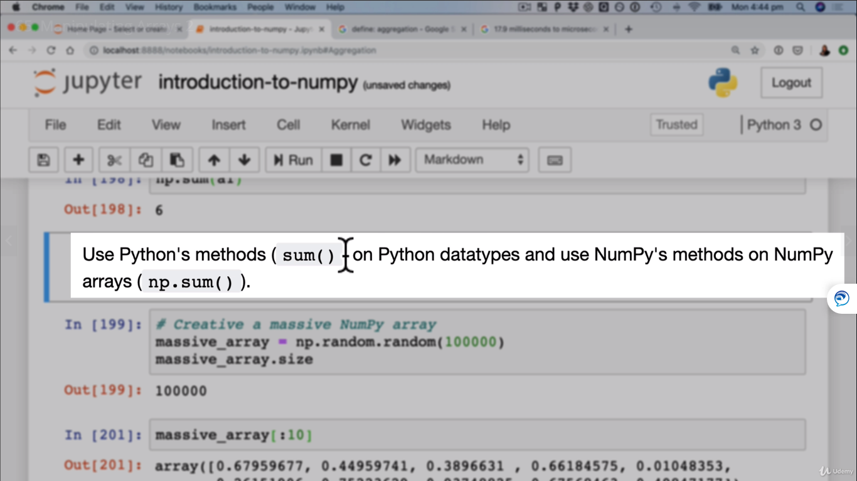

**Np mean,variance,std deviation**

Standard deviation = square root of variance.

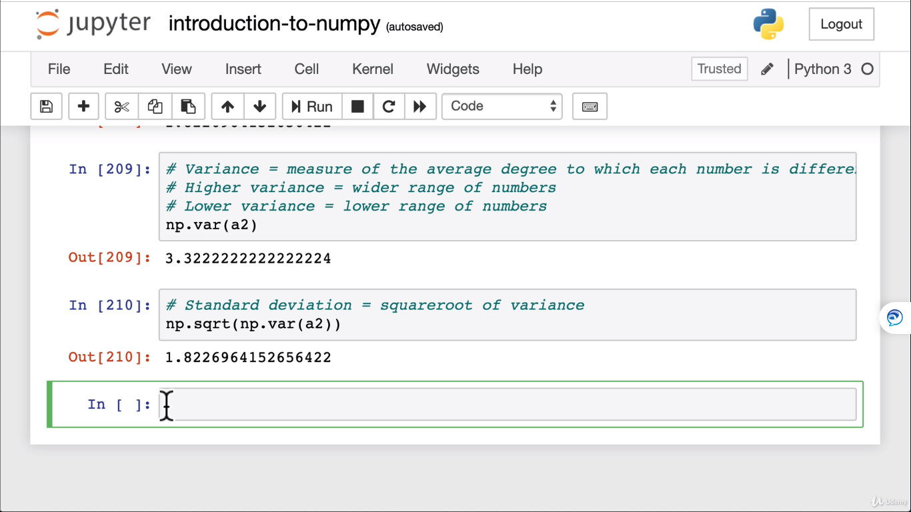

**Variance and standard deviation are measuring the spread of data.**

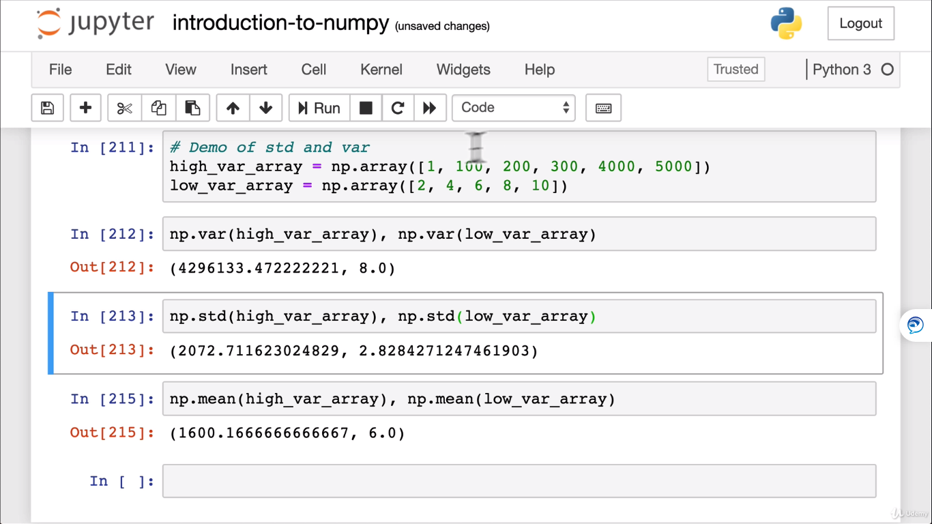

**histogram**

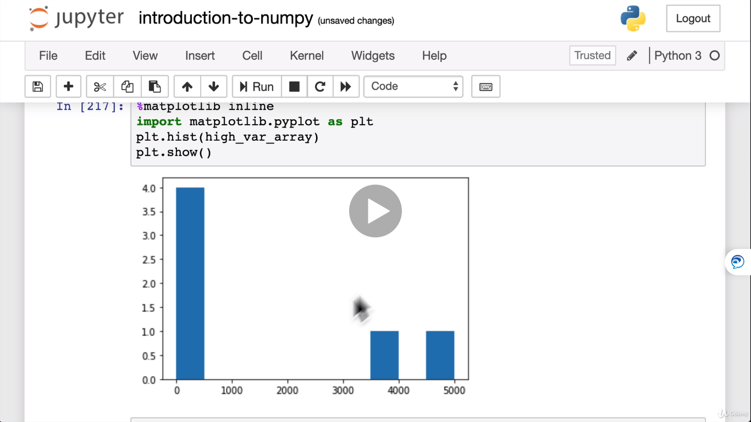

**Reshape and Transpose:**

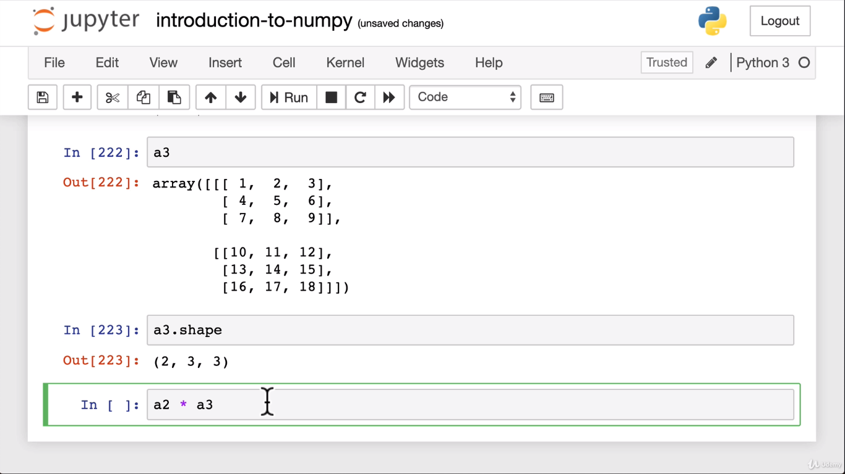

**Reshape**

**We need to reshape based on broadcasting rules:**

**Two elements are equal or one of them has to be 1**

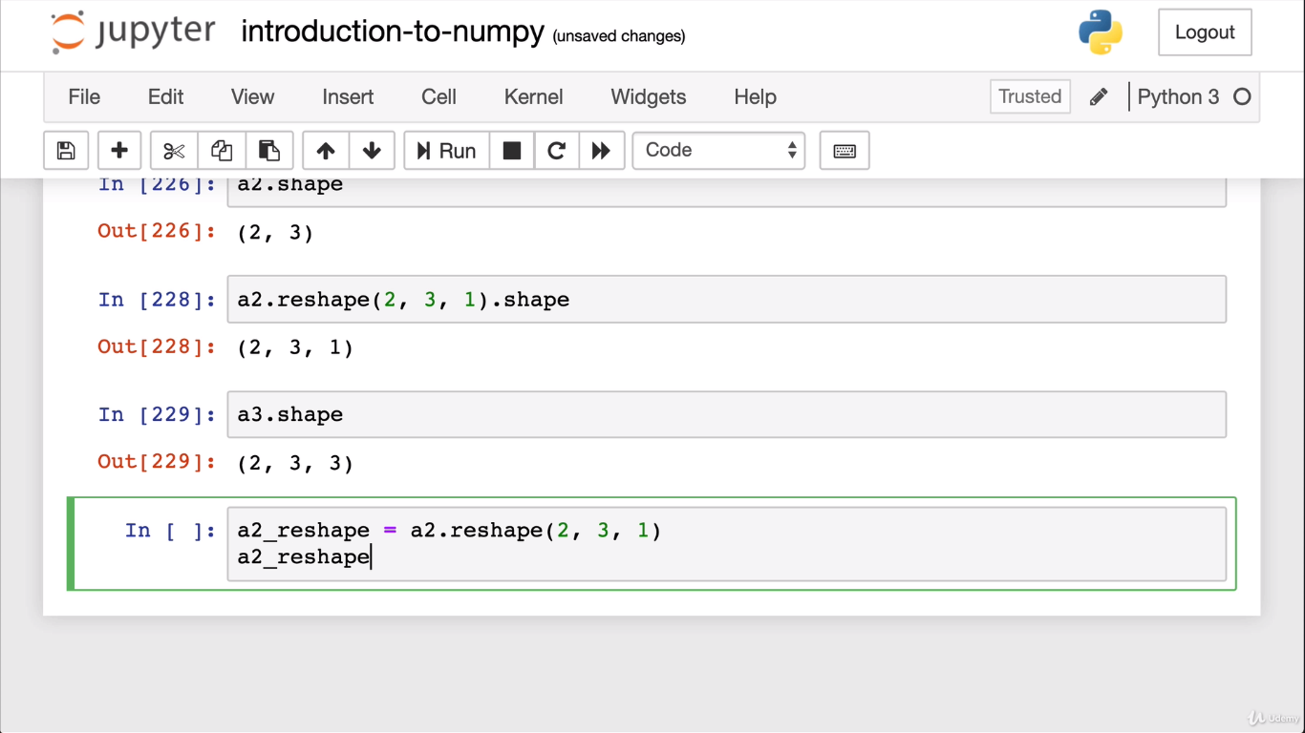

Now the shape matched .

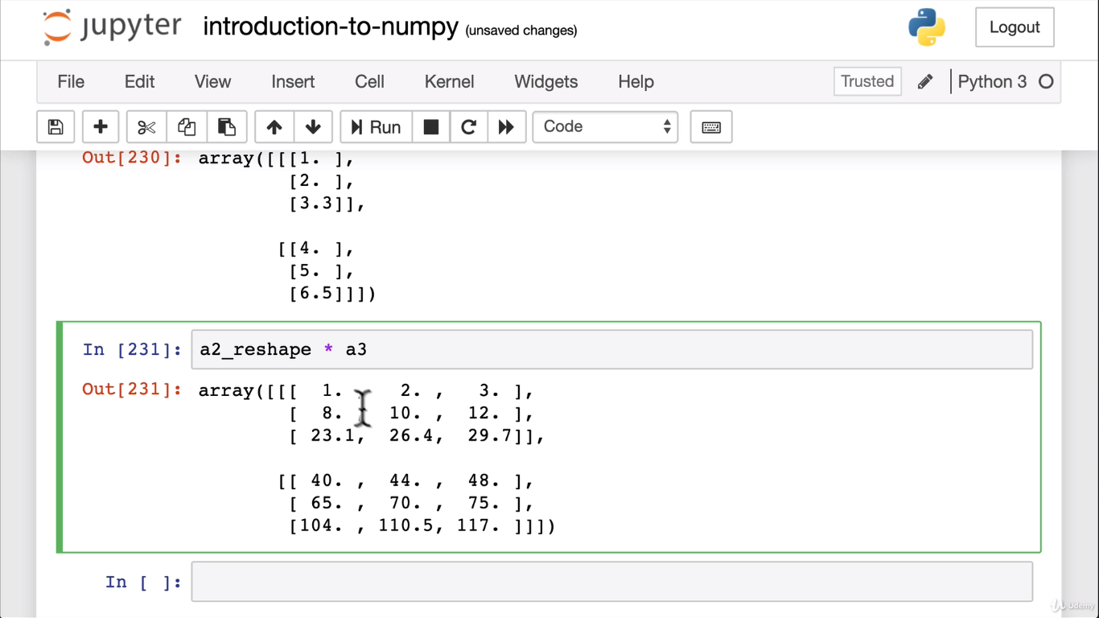

**Transpose:**

**Transpose switches/swaps the axis**

A2.T

A2.T.shape

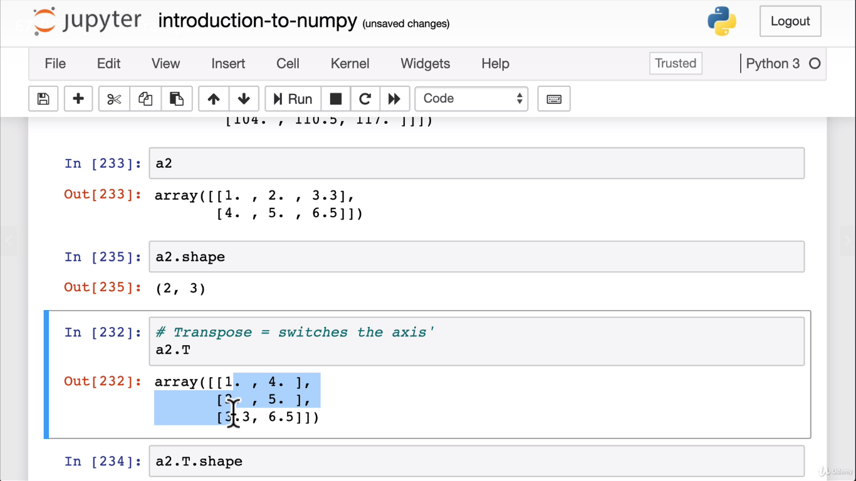

**Dot Product**

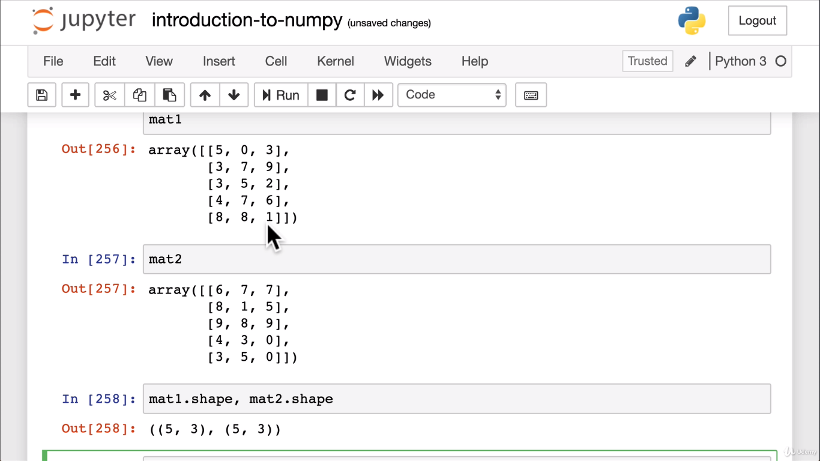

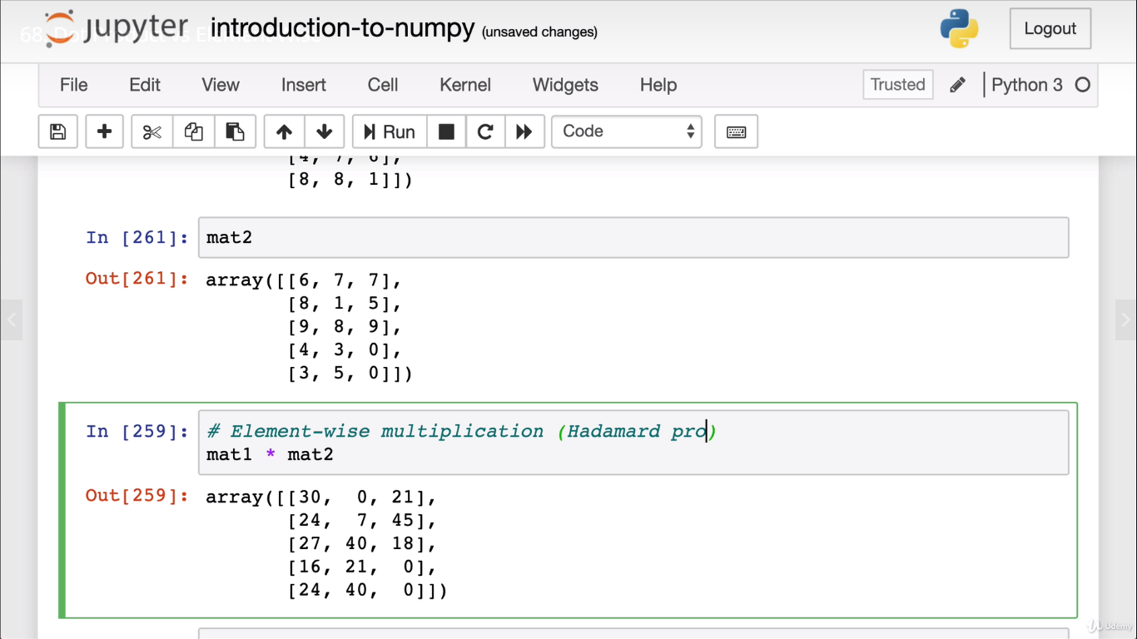

Np.dot(mat1,mat2)

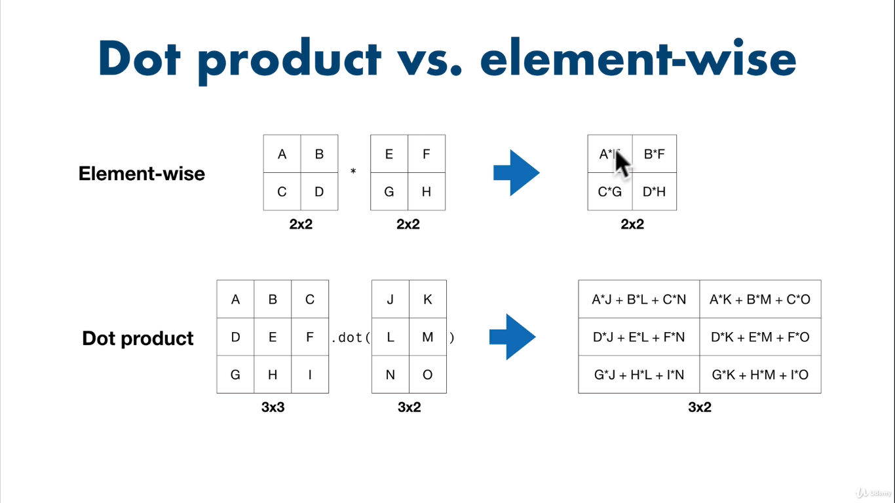

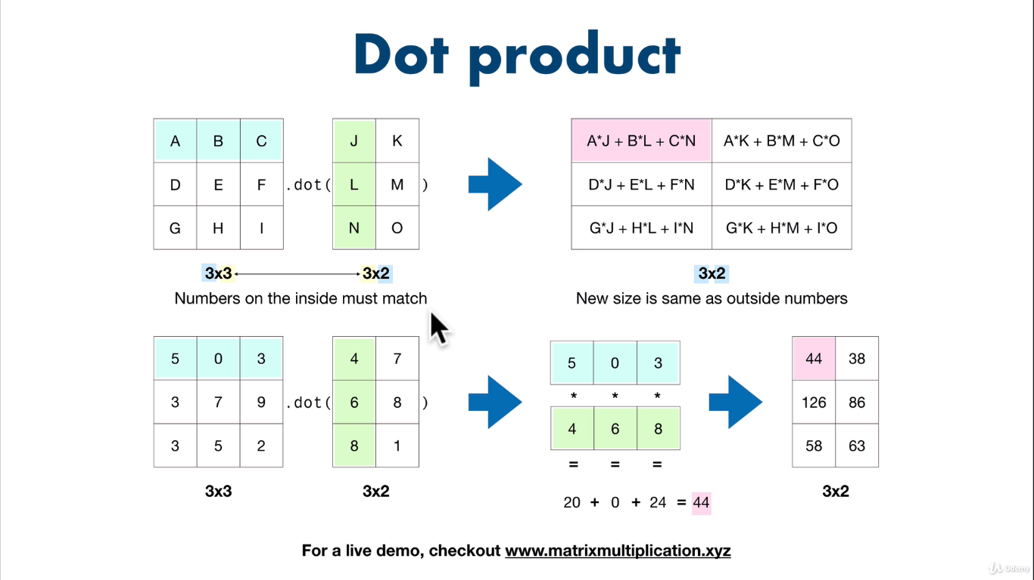

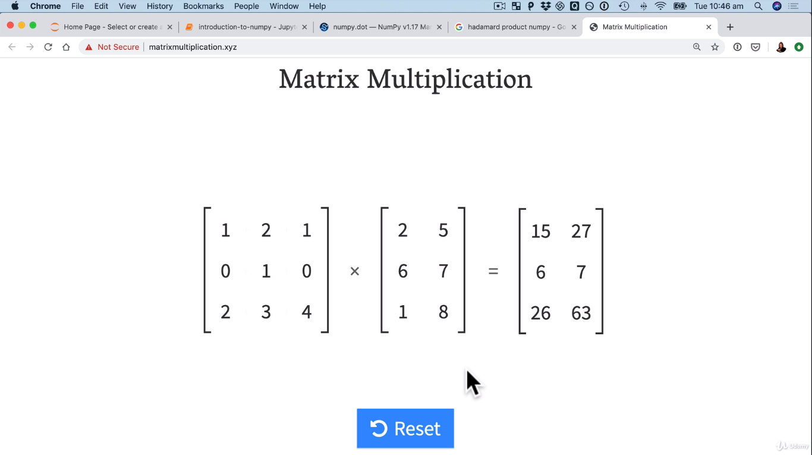

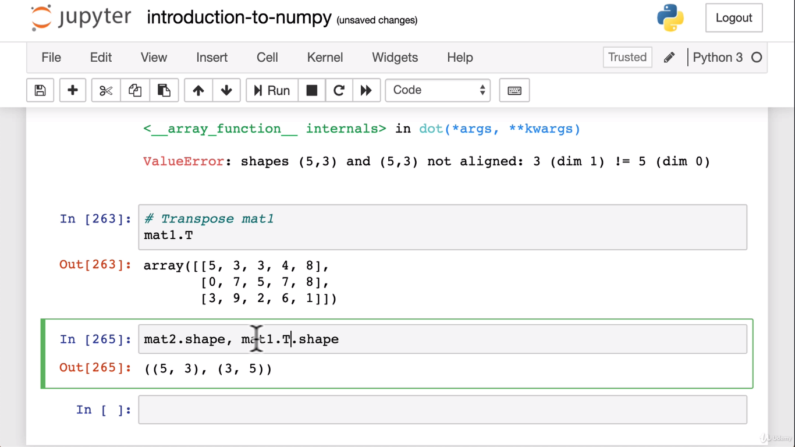

**product works after Transposing:**

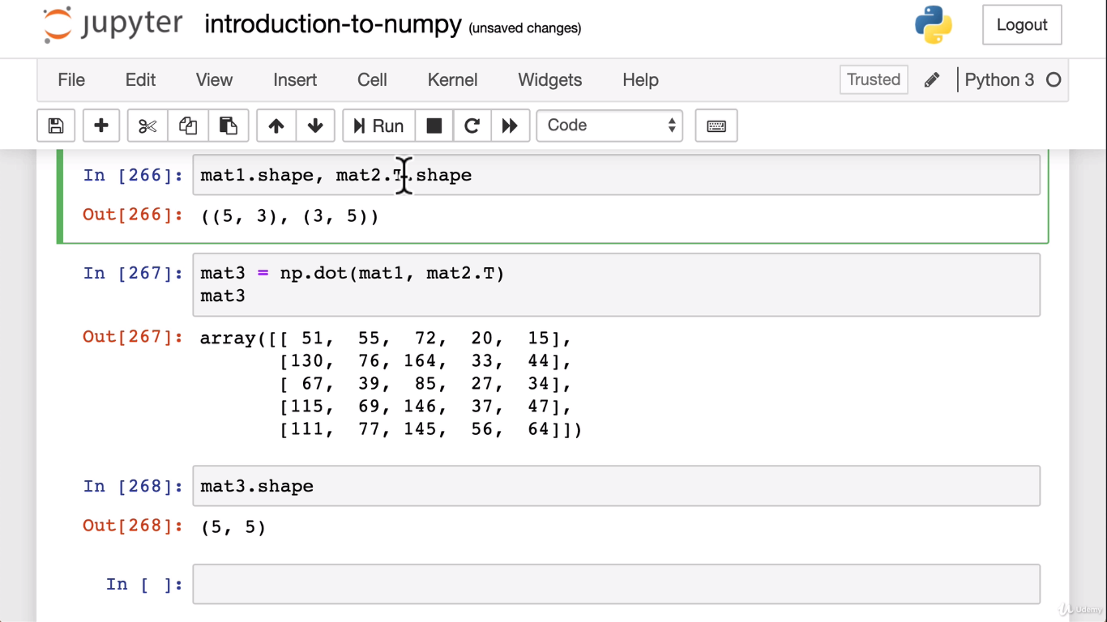

**Nut Butter sales exercise:**

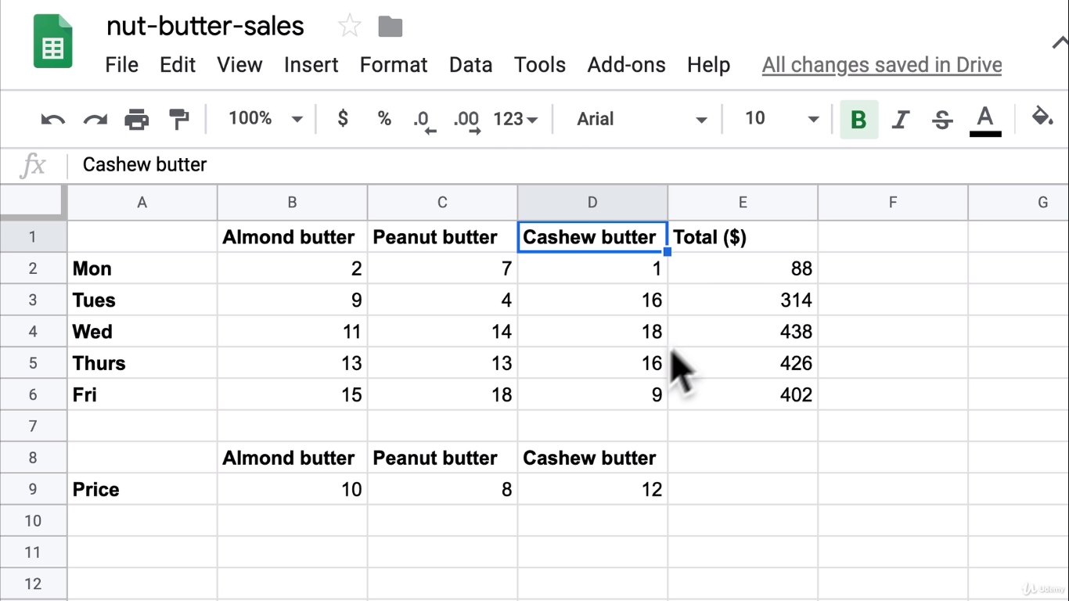

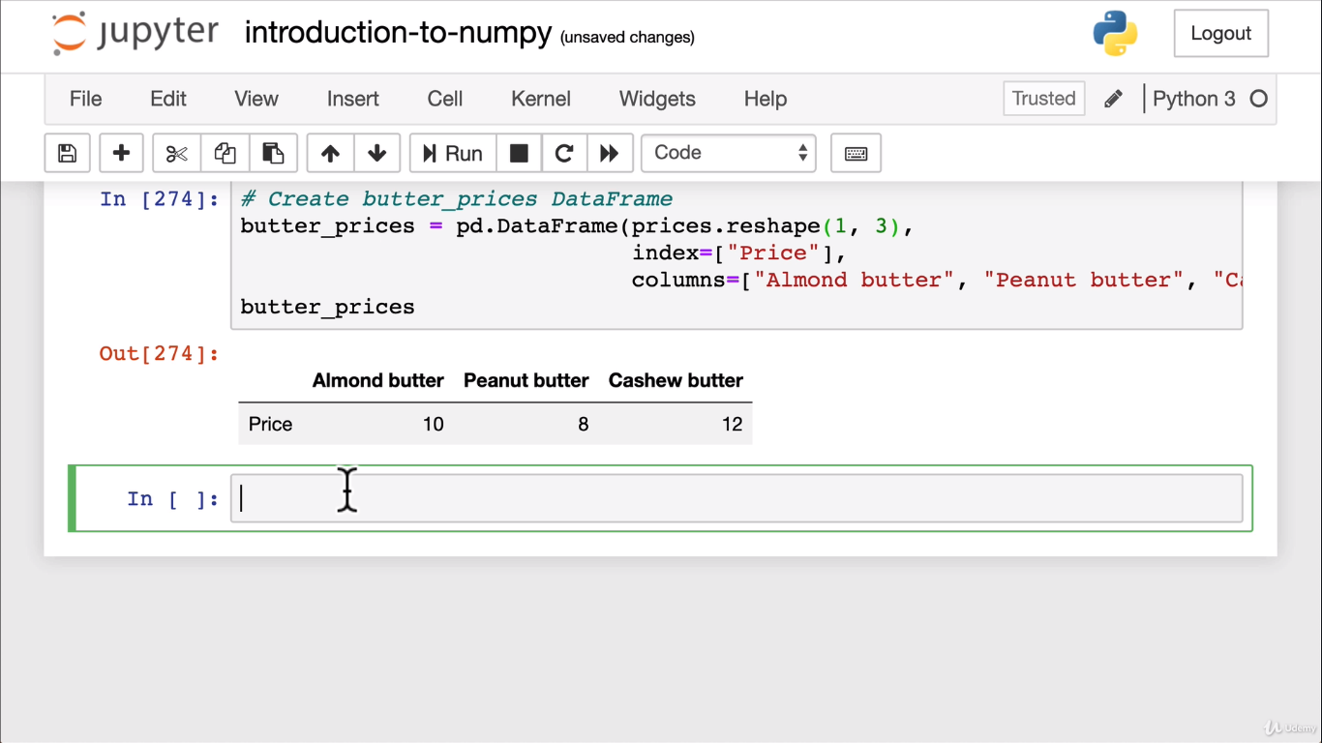

**Total _Sales:**

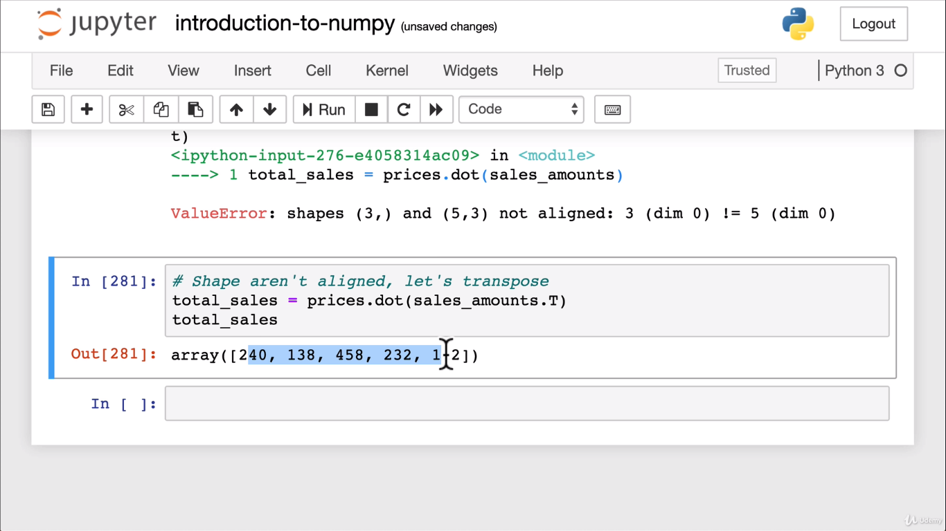

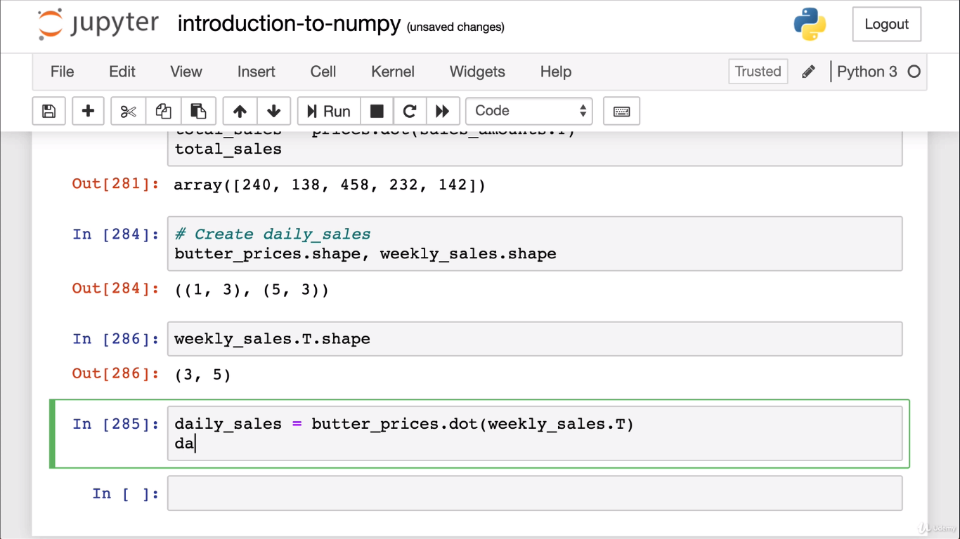

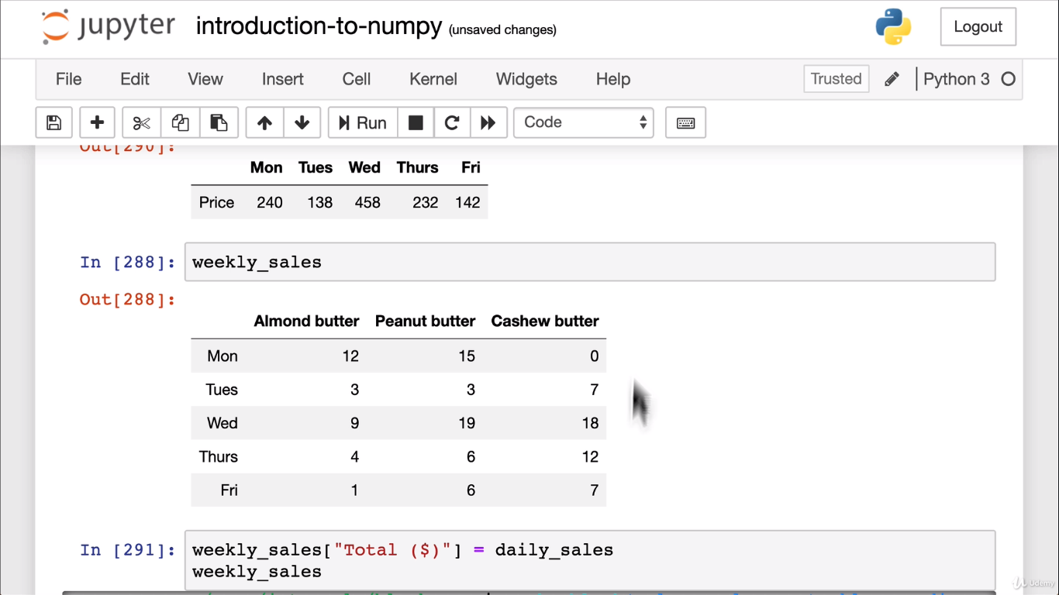

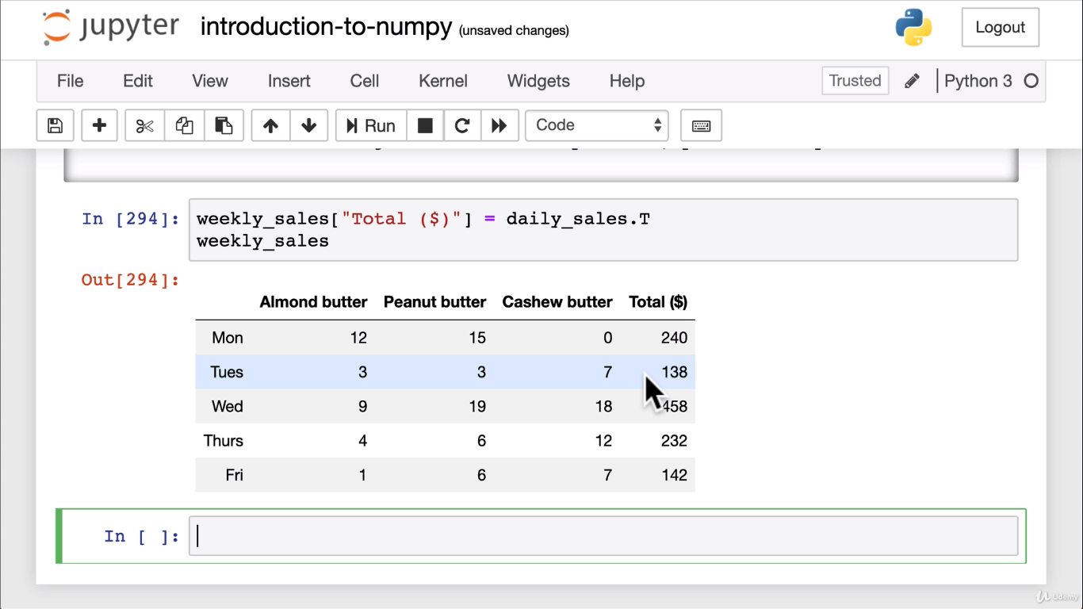

**Comparison Operators:**

A1 > a2

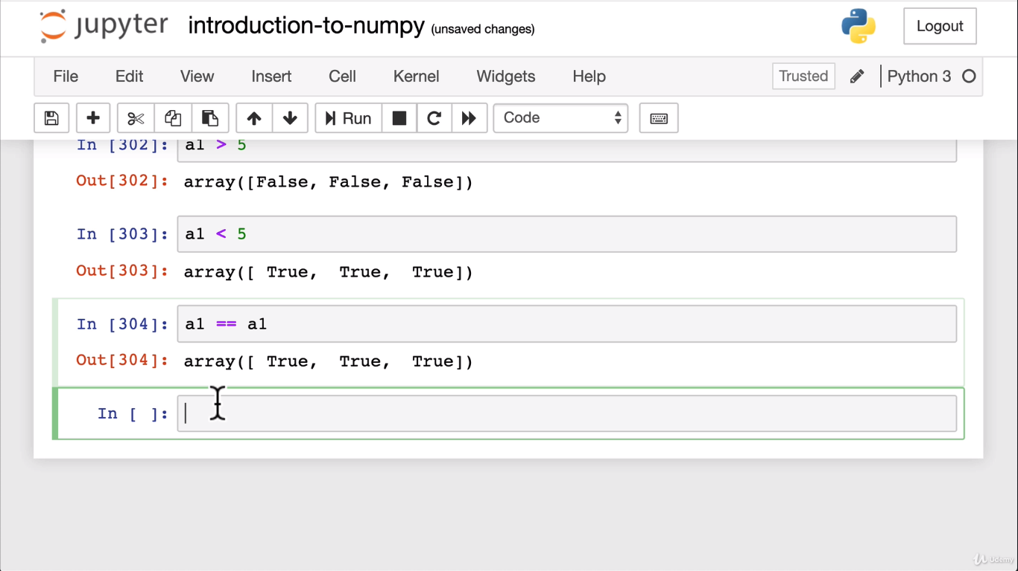

**Numpy sorting:**

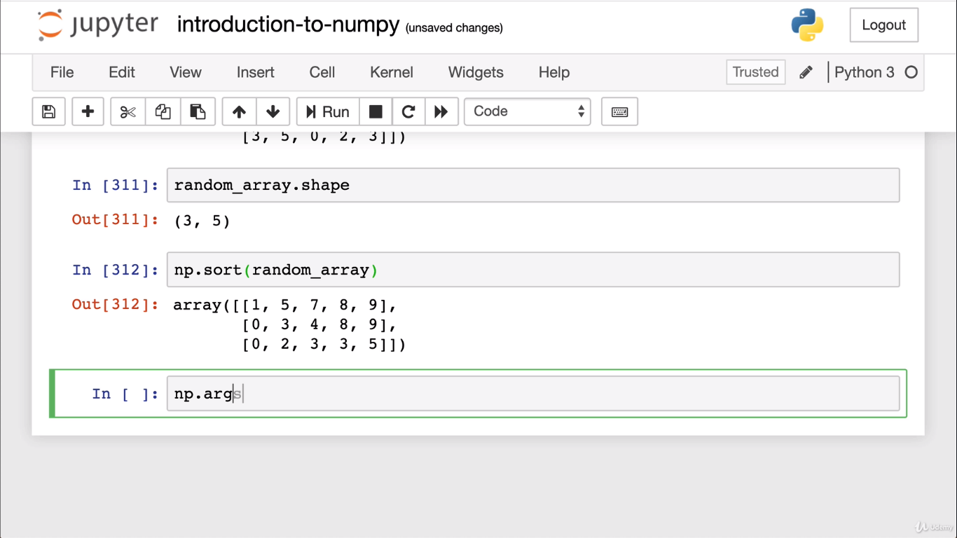

**Argsort array ( sorting by indexes)**

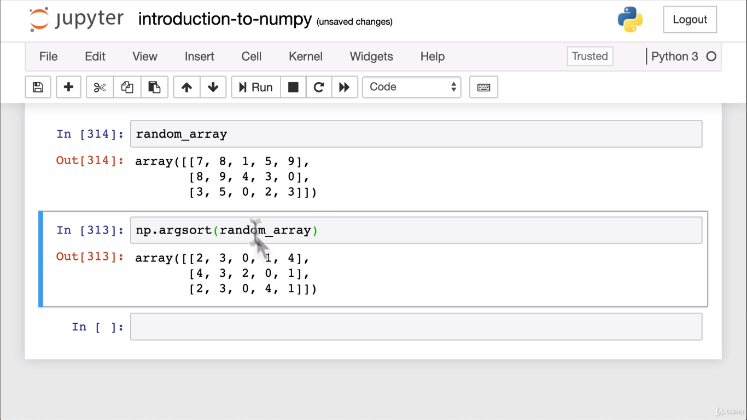

**Argmin and argmax**

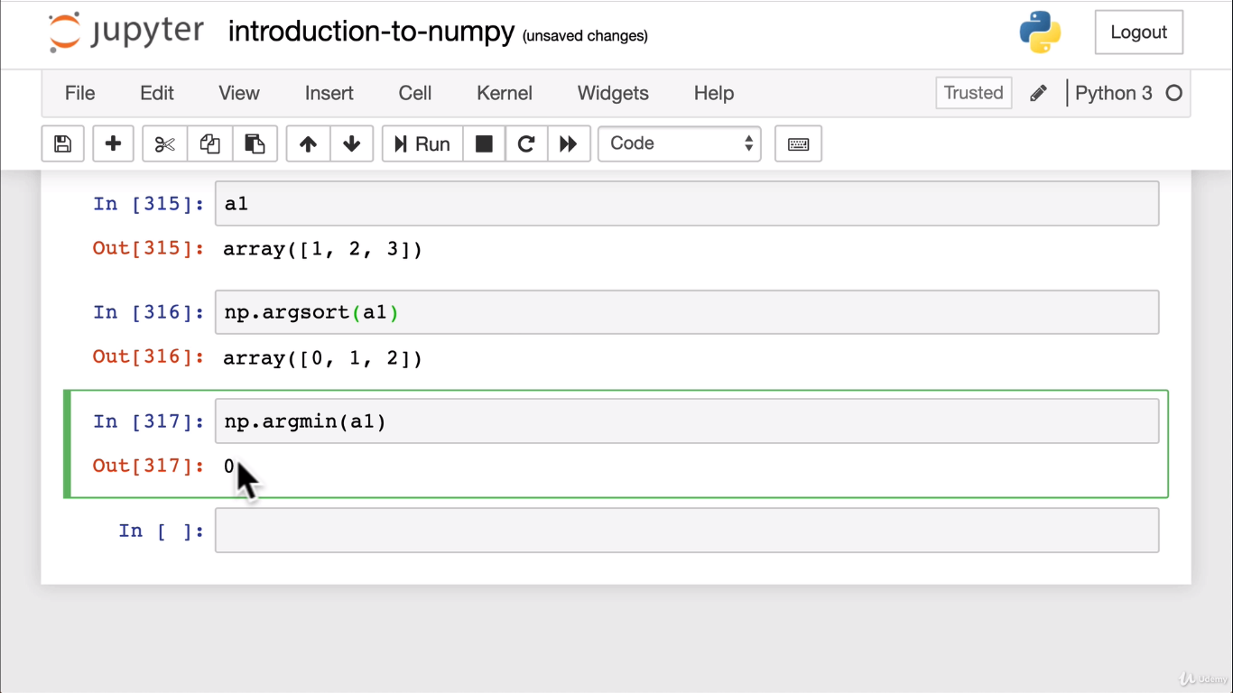

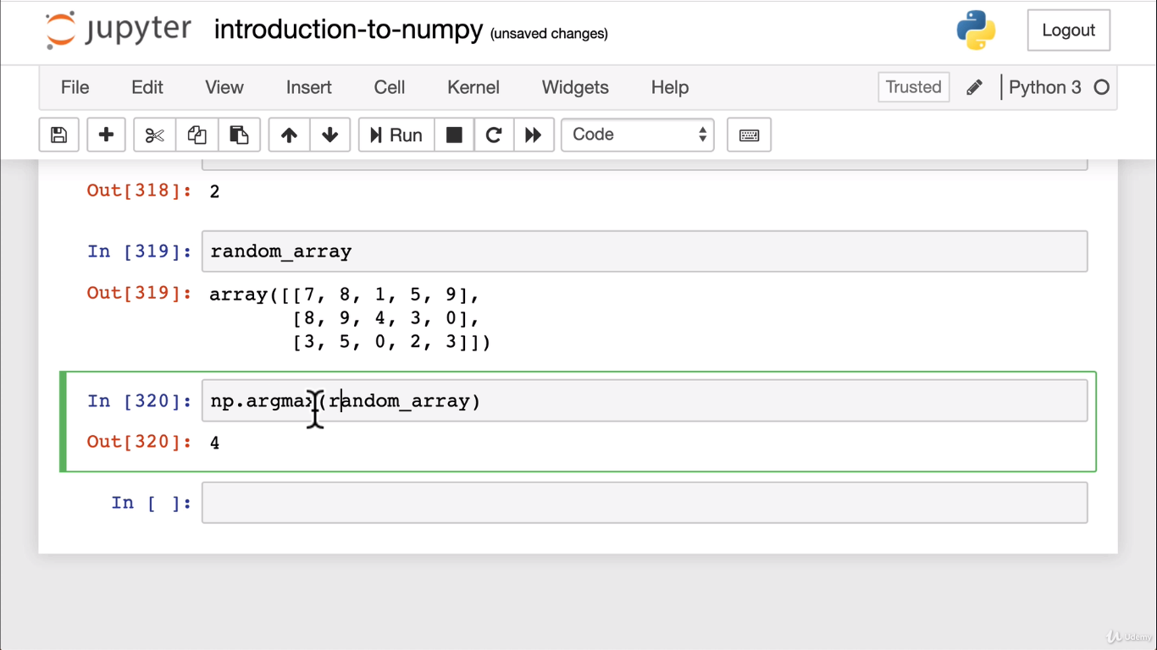

**Argrmax for columns =axis 0**

**Argmax for rows = axis1**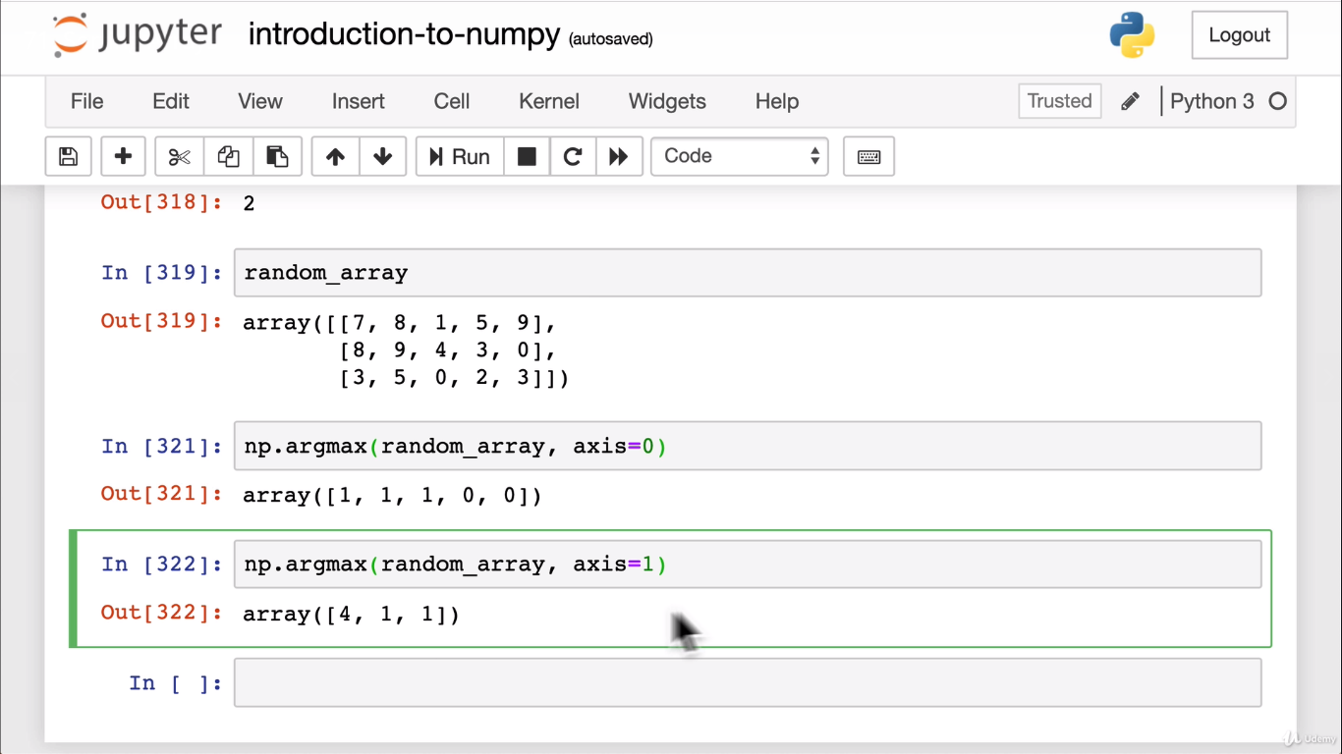

**Example of convert of photo to numbers**

**Through numpy:**

**To import an image:**

<img src=”images/panda.png”/>

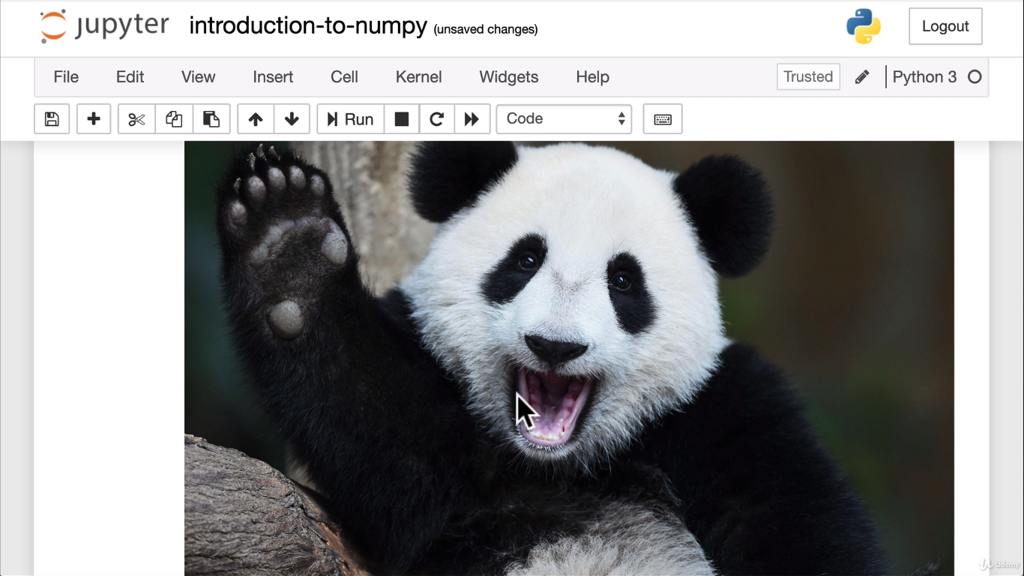

**Now lets turn this image into numpy array:**

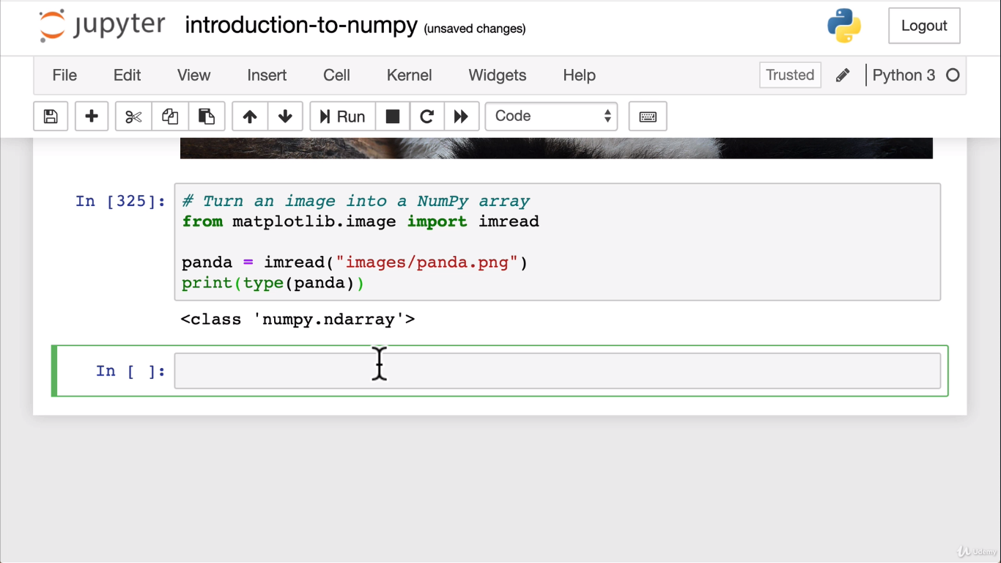

**To get first 5 arays from the picture:**

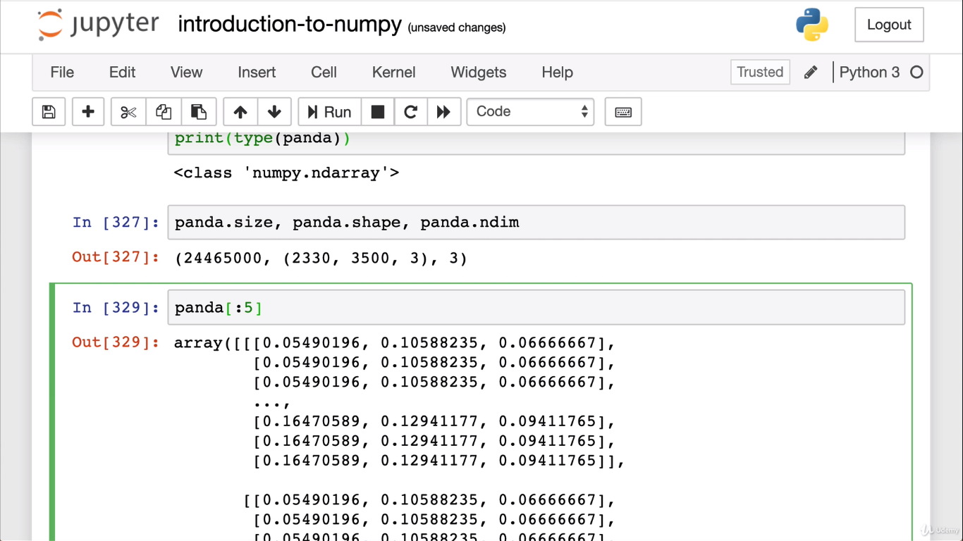

Imread function can read a photo and turn into a numpy ndarray and that is what we use in machine learning.

**Matplotlib:**

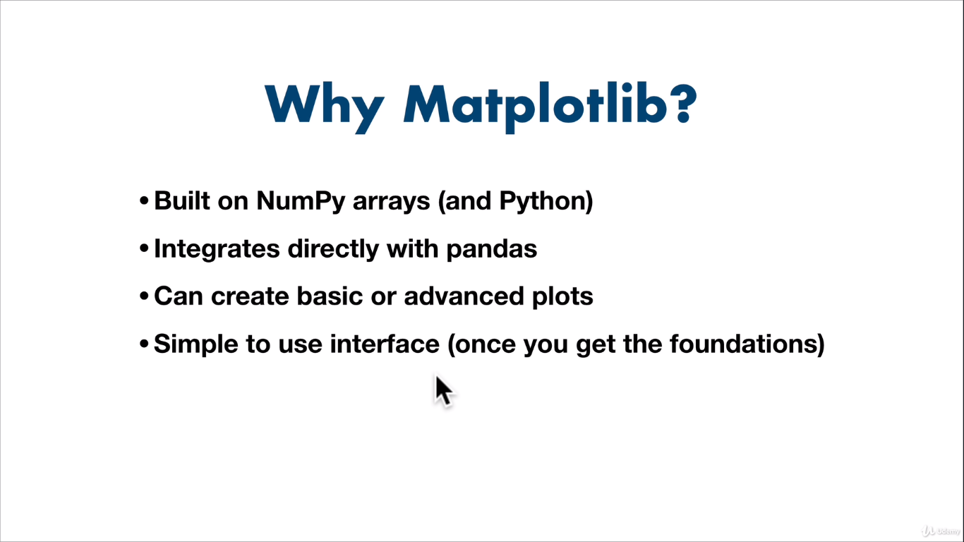

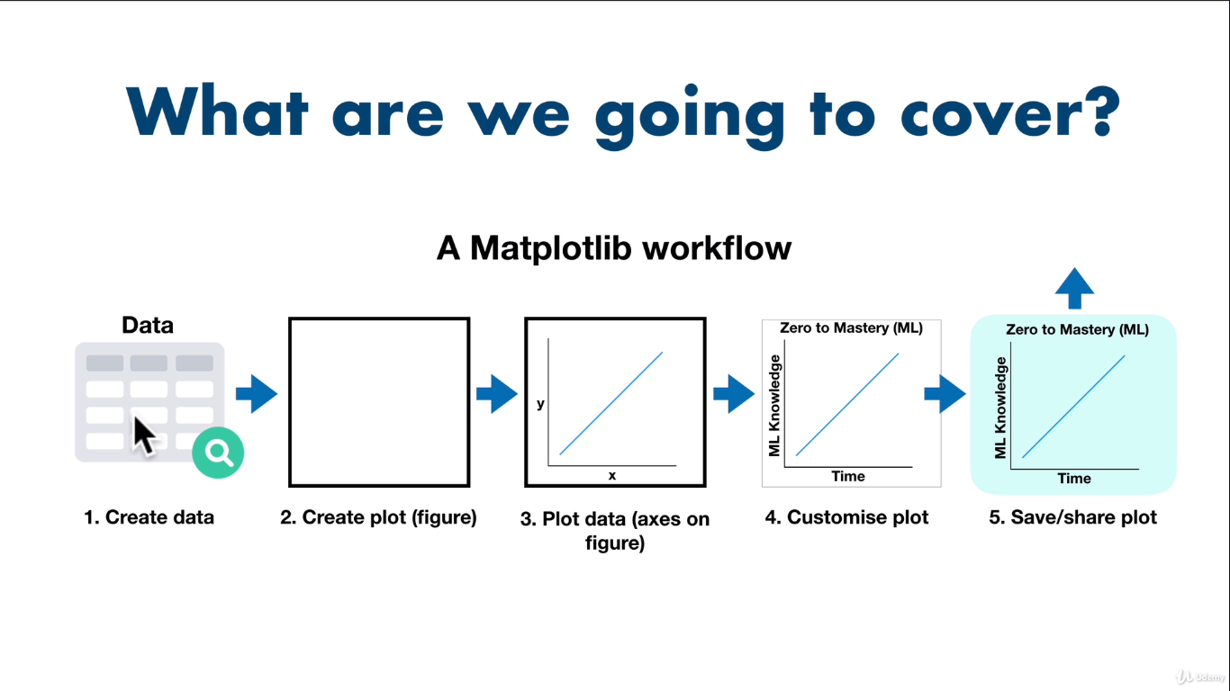

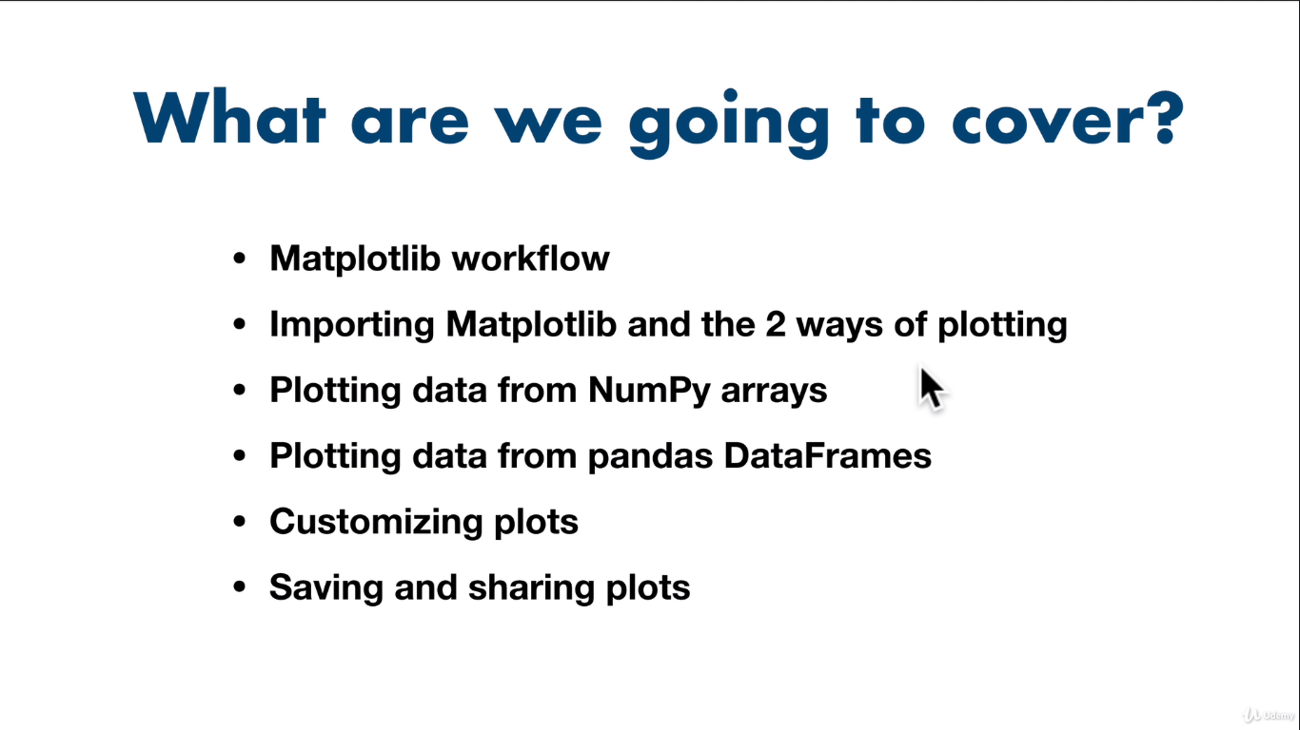

**Importing and using matplotlib**

%matplotlib inline **🡪 This will say display the visuals with in jupyter notebook**

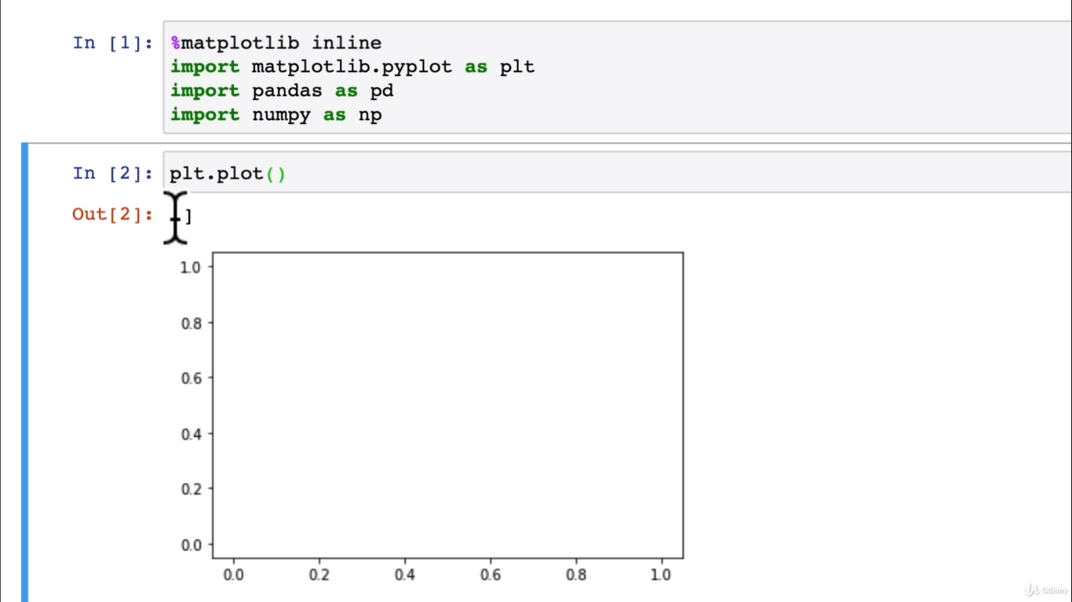

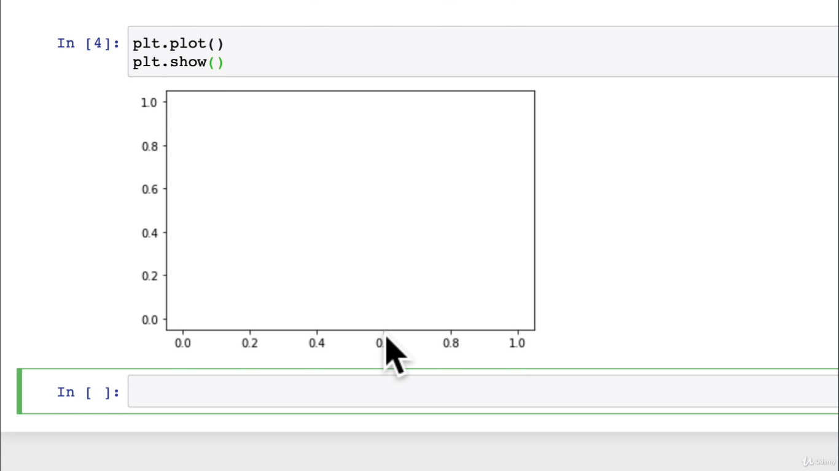

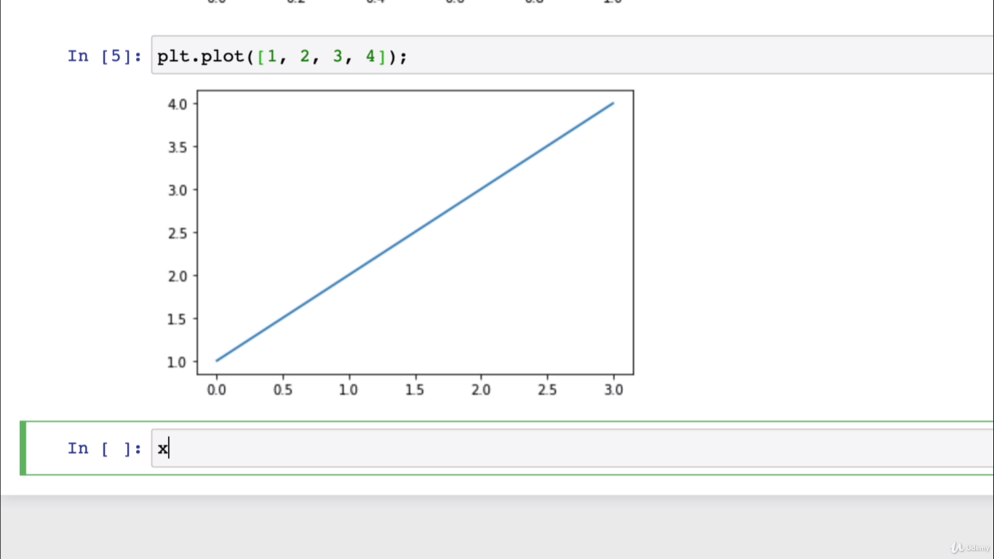

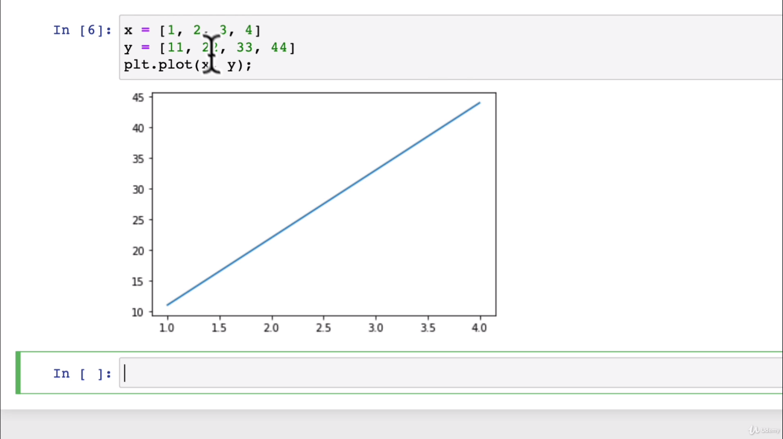

**2nd method:**

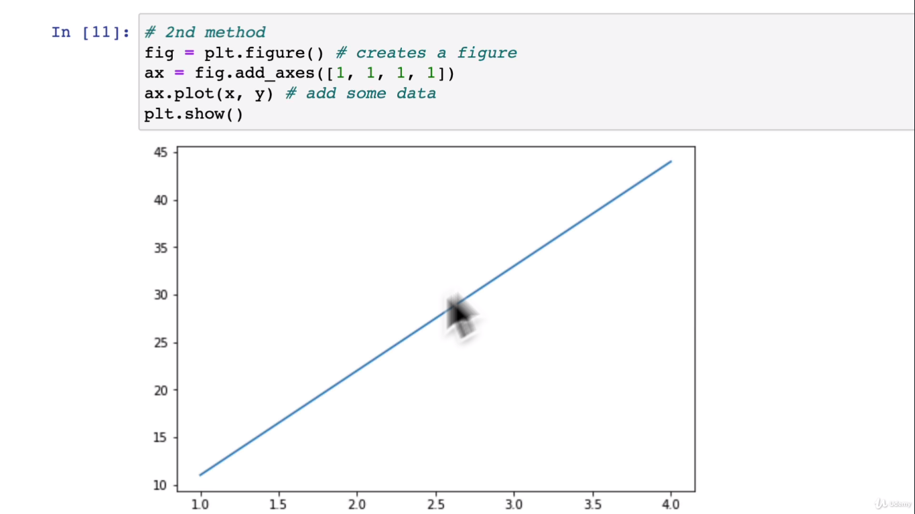

**3rd method: (Recommended)**

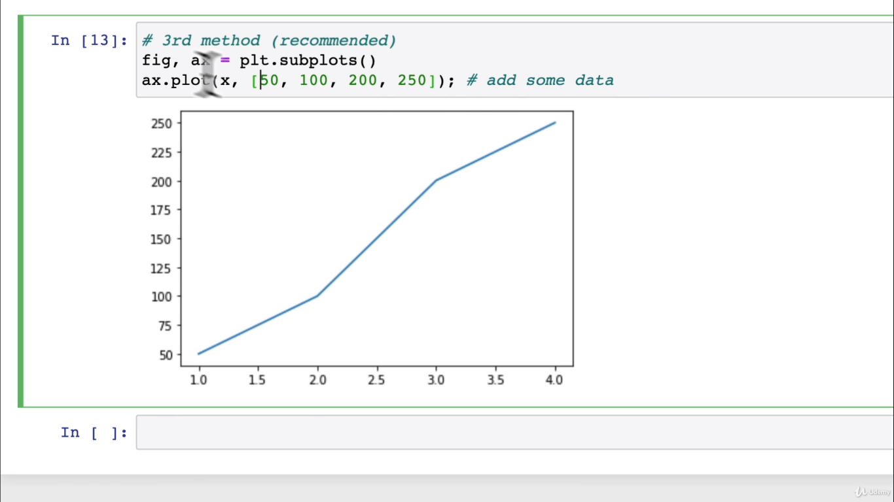

**Convert the categories (strings) to numbers.**

from sklearn.preprocessing import OneHotEncoder

from sklearn.compose import ColumnTransformer

even though doors are numerical, it is a category

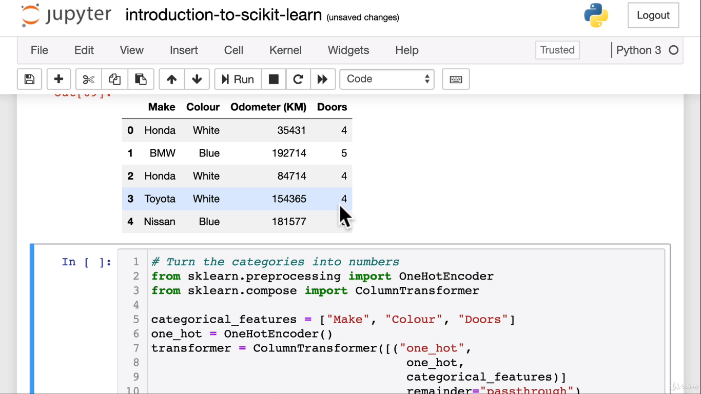

This is spitting out an array , let’s put this in to a data frame to make sure if it makes sense.

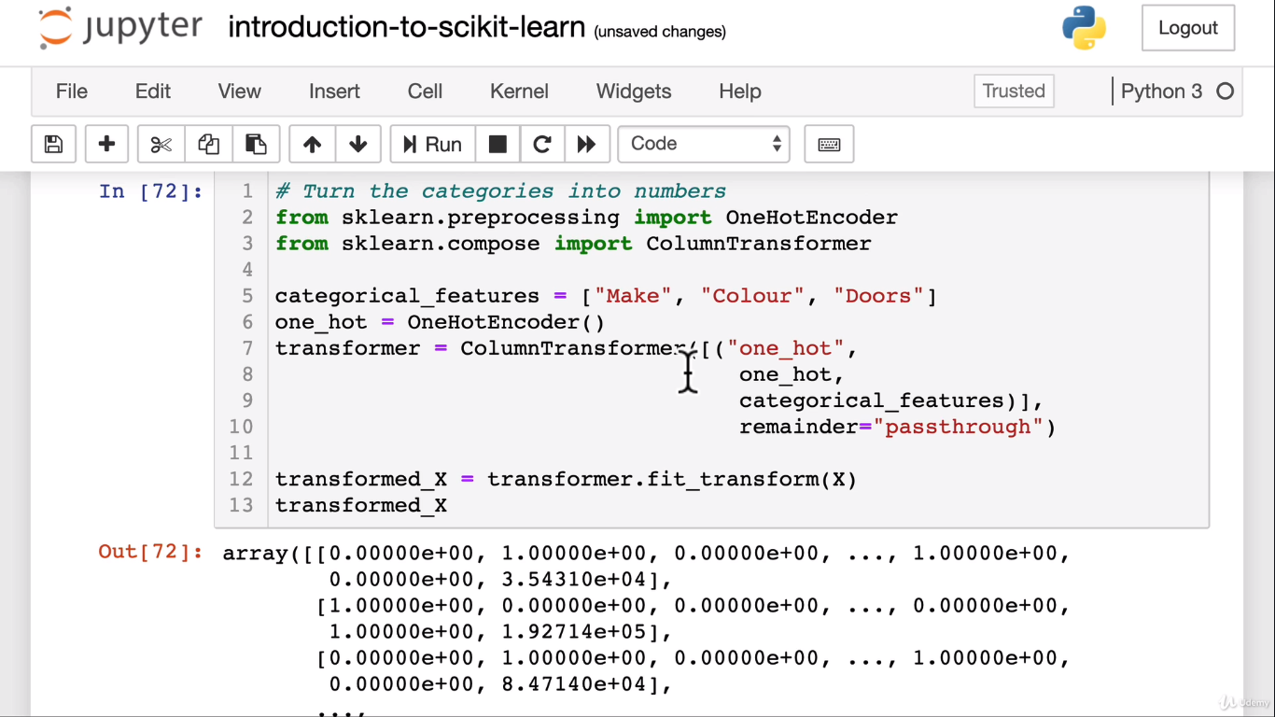

pd.DataFrame(transformed_X)

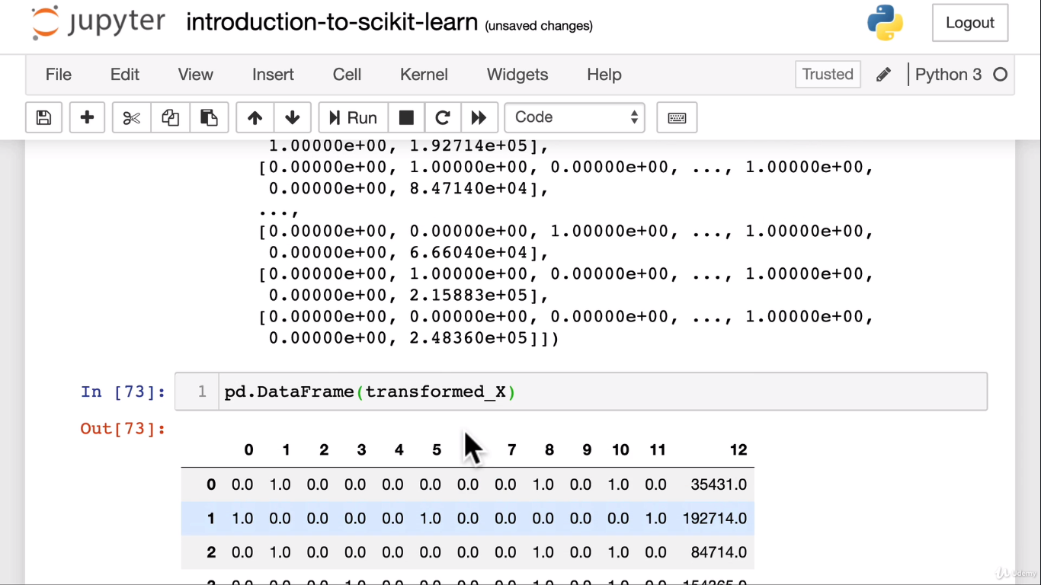

Here we are saying hey columnTransformer() apply oneHotEncoder() to apply on categorical_features and for the remainder of the columns do not do anything and just pass through.

What is oneHotEncoding

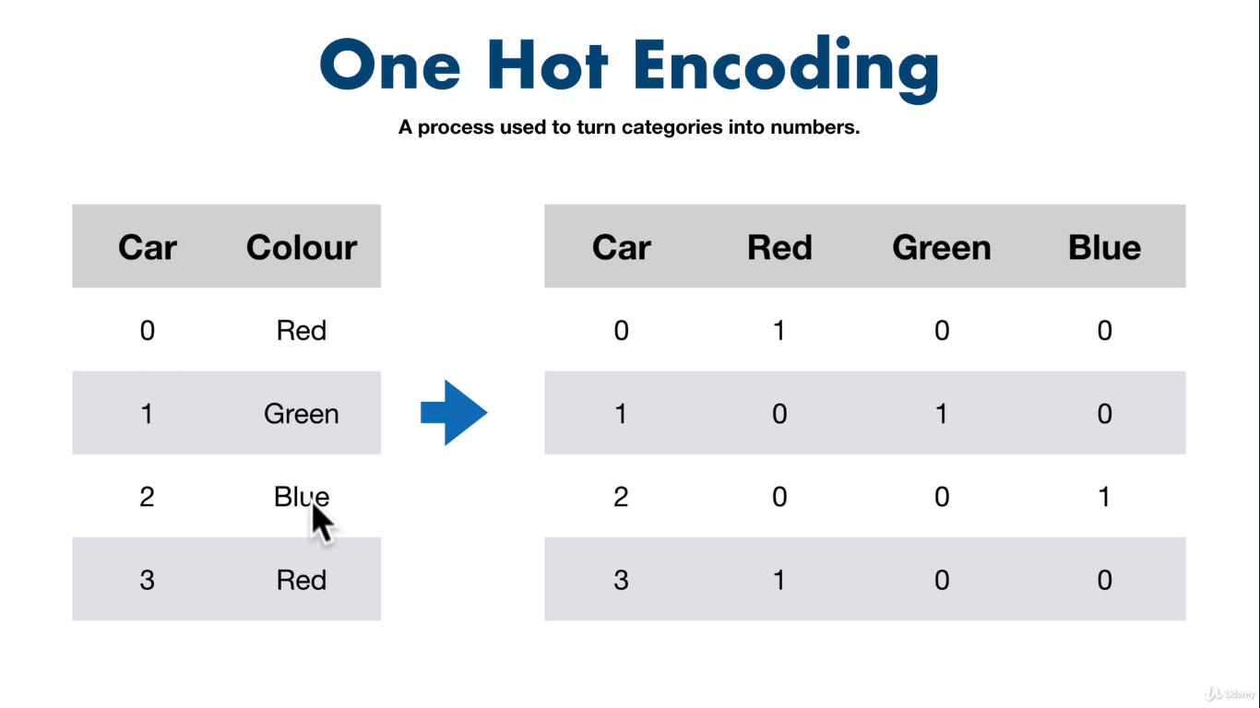

It has converted all strings to numbericals which the machine can understand

**Now there is one more way of doing this using pandas**

dummies =pd.get_dummies(car_sales[[“Make”,”colour”,”Doors”]]

dummies

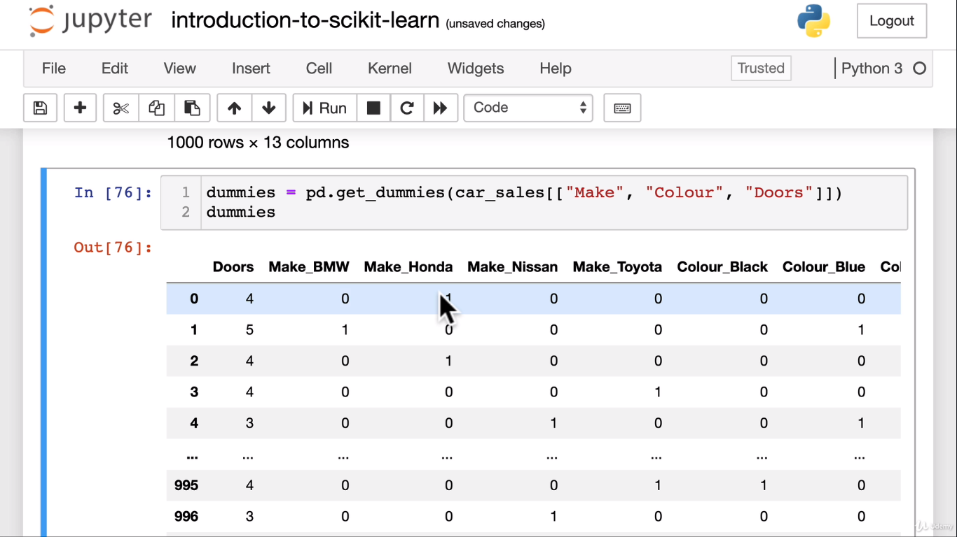

**Let’s refit the model**

np.random.seed(42)

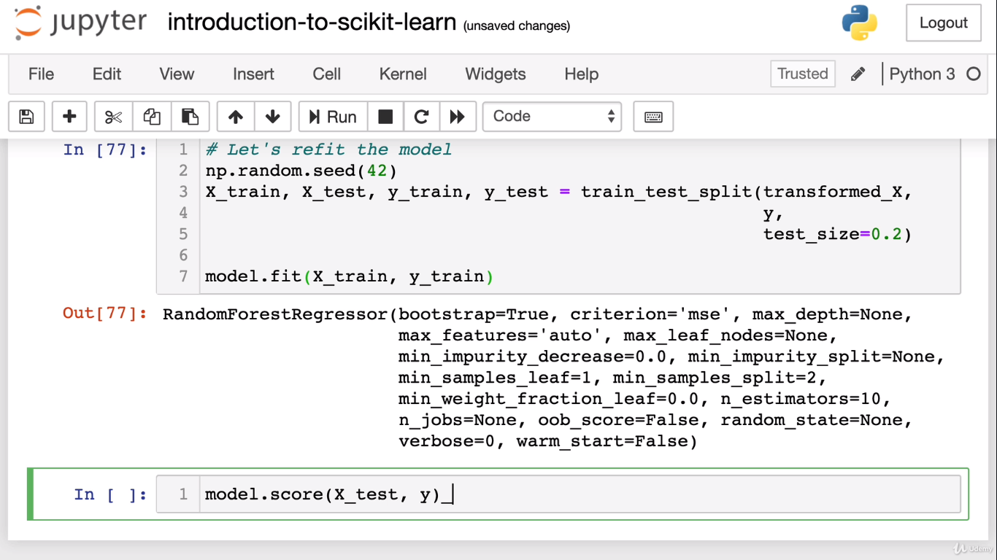

It got a below score of 0.30 ( which is just 30% accuracy)

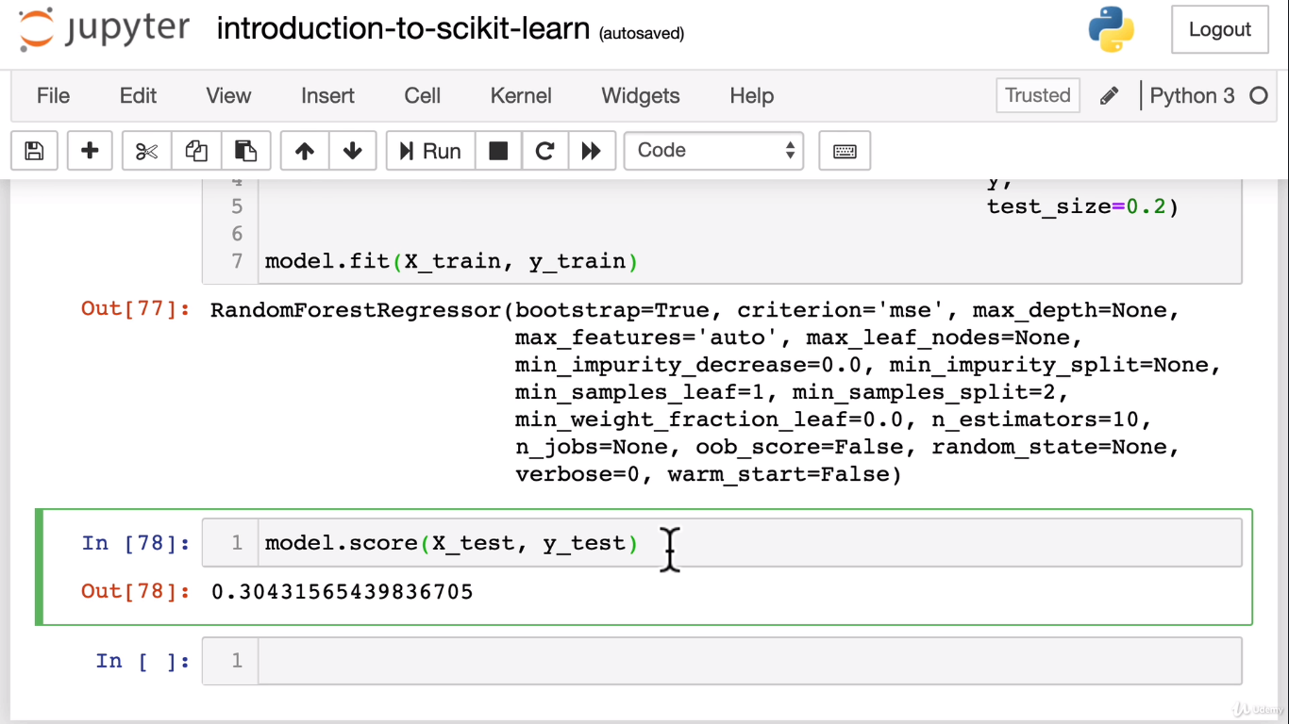

**Missing values:**

car_sales_missing.isna().sum()

